# Ukraine

The Ukrainian economy grew by around 3% each year from 2015 to 2018. However, the country remains poor by European standards with a *per capita* GDP that is just one quarter of the EU average on a purchasing power parity basis.

Ukraine has considerable reserves of coal and lignite, estimated at 34.4 billion tonnes in the Donetsk coal basin (by far the most significant), the Dnieper and Lviv-Volyn coal basins, as well as the Dnieper-Donetsk and Transcarpathian coal basins. It ranks seventh in the world after the United States, China, India, Russia and Australia in terms of proven coal reserves of which steam coal accounts for 70% and coking coal 30%. Exploitable reserves are competitive with imported coal.

The country also has large fossil gas reserves estimated at almost one trillion cubic metres – second only to Norway in Europe. These lie onshore, mainly in the Dnieper-Donetsk basin, offshore under the Black Sea, and as shale gas in the Donetsk and Kharkiv oblasts (Yuzivska gasfield) and in the Lviv and Ivano-Frankivsk oblasts (Olesska gasfield). Efforts to exploit these reserves were set back by the ongoing conflict in eastern Ukraine, but a new programme of deep drilling at the Machukhske gasfield in the Poltava oblast promises gas from almost 6 000 metres, adding to other conventional production which totalled 21.0 bcm in 2018.

One third (31.3%) of the country’s total primary energy supply came from fossil gas in 2018, with coal (31.2%) and nuclear power (22.7%) also being important. Oil (11.4%) and renewable energy sources (3.4%), including hydro, had rather small shares in total energy supply. The *Energy Strategy of Ukraine to 2035*, adopted by the government in 2017, envisages a significant role for coal in primary energy supply: 22.0% in 2020, 16.1% in 2025 and 14.3% in 2030. The strategy aims to increase the share of renewable energy sources to 20% by 2035.

With a 29.5% share in 2018, coal is the second most important energy source for electricity generation in Ukraine after nuclear power which accounted for 54.5% of gross generation. Ukraine’s fifteen nuclear reactors with a total capacity of 13.1 GW at four sites are operated by state-owned ENERGOATOM. Hydro power (7.7%) and fossil gas (6.4%) were also important in 2018, with other sources accounting for the remaining 1.9% of gross generation, mainly wind power and oil-fired power generation.

By 2025, the technical integration of the Ukrainian and continental European electricity and gas markets is planned, with cross-border transmission network capacity amounting to at least 15% of Ukraine’s primary energy supply.

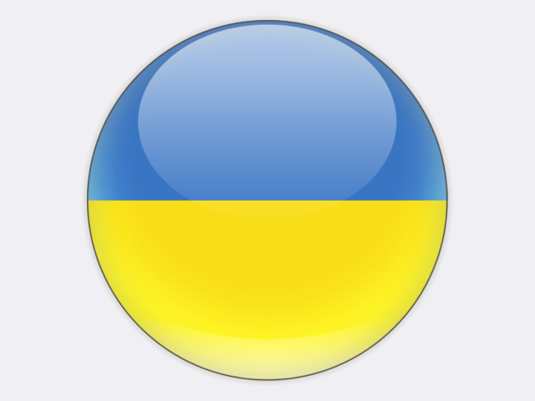

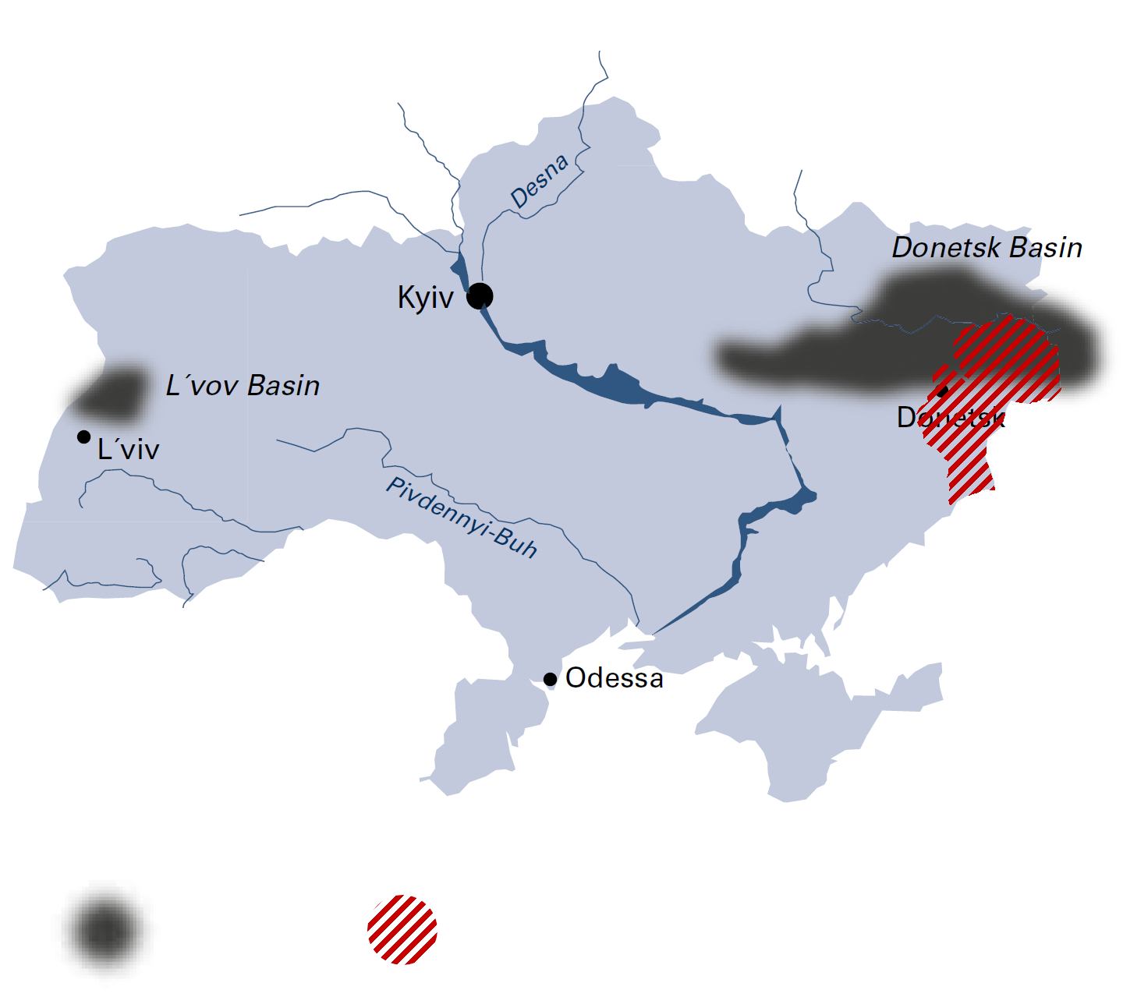

*Hard coal*

*Temporarily occupied territories of   
Donetsk and Lugansk oblasts*

|  |  |  |
| --- | --- | --- |
| General data |  | 2018 |
| Population | million | 42.2 |
| GDP | € billion | 110.8 |
| Per capita GDP | €/person | 2 600 |

## Hard coal

Hard coal deposits in Ukraine are characterised by their great depth – operations take place at 500 to 1 000 metres – and by thin seams of 0.8 to 1.0 metre. In 2018, coal was mined at forty-seven mines, of which forty-two produced G‑grade bituminous coal. The rest produced K‑grade coking coal and Zh‑grade bituminous coal. Total coal production in 2018 was 26.1 million tonnes, comprising 21.6 million tonnes of steam coal and 4.6 million tonnes of coking coal.

Since spring 2014, the conflict in Donbas left Ukraine with little control over its coal-mining assets in the temporarily occupied territories of Donetsk and Luhansk oblasts where all anthracite mines are located. As of March 2017, Ukraine completely lost these assets. Production data for the lost coal mines in Donbas is not known, but some coal is likely exported via Russia and the breakaway region of Abkhazia.

The consumption of G‑grade coal has grown as power plants designed for anthracite have been converted to use G‑grade coal. This trend will likely continue in the future as Ukraine plans to completely replace anthracite with G‑grade coal whose production is not at risk from hostilities. According to the *Energy Strategy of Ukraine to 2035*, increasing the production of G-grade coal by 5 million tonnes would allow the complete replacement of anthracite in power generation.

Since the start of the military conflict, Ukraine has been importing steam coal for electricity production. In 2018, 5.5 million tonnes were imported: 4.1 million tonnes from Russia, 0.8 million tonnes from the United States and 0.3 million tonnes from South Africa. A further 15.9 million tonnes of coking coal were imported, bringing total coal imports in 2018 to 21.4 million tonnes.

In 2018, DTEK ENERGY, the largest private energy company in Ukraine, produced 24.1 million tonnes of coal. This was lower than previous years primarily due to the loss of T-grade and A-grade coal production from mines in the temporarily occupied territories, despite increased production of G-grade coal by the company. In Ukraine, DTEK ENERGY operates sixteen coal mines and five coal preparation plants through subsidiaries including DTEK PAVLOGRADUGOL in Dnipropetrovsk oblast and DTEK DOBROPOLYUGOL in Donetsk oblast where the company also operates the Belozerskaya mine.

Coal-fired power plants are owned and operated by three companies: DTEK ENERGY which has nine coal power plants with a total capacity of 16.3 GW, excluding Zuivska power plant over which DTEK lost control in 2017, state-owned CENTRENERGO with three coal power plants (7.6 GW), and DONBASENERGO which operates a single 880 MW coal power plant.

The Ministry of Energy and Coal Industry of Ukraine is responsible for formulating coal policy. The main policy document for the coal industry remains government decree No. 733-r of 24 May 2017 on the “Concept for restructuring and developing the coal industry over the period to 2020”. The aim of this concept is to take systematic measures to increase coal supply, raise productivity and transform the coal industry so that it is economically sustainable. At the same time, measures are planned to address the environmental and social problems in coal-mining regions and create a favourable investment climate for the privatisation of state-owned coal mines. According to the secretariat of the Cabinet of Ministers of Ukraine, there are 102 state-owned coal mines, but most are located in the temporarily occupied territories. Only thirty-three state-owned coal mines are controlled by the government and only four of these are profitable.

Coal is sold under contract between mining enterprises and consumers, and through DERZHVUGLEPOSTACH SE which was established by the government to trade coal produced at state-owned coal mines. The bulk of the saleable output from state-owned coal mines is distributed at fixed prices. Thus, loss-making mines are cross-subsidised by profitable mines, although losses are not fully covered.

In 2018, the average production cost at state-owned mines was 3 135 UAH/tonne. According to the ministry, the cost of producing 4 million tonnes of raw coal was UAH 9.4 billion, while the saleable output of 3 million tonnes was worth only

Ukraine

|  |  |  |
| --- | --- | --- |
| Coal resources and reserves |  | as at 1.1.2018 |
| Total resources hard coal | Mt | 81 045 |
| Total resources lignite | Mt | 7 717 |
| Reserves hard coal | Mt | 32 039 |
| Reserves lignite | Mt | 2 336 |

|  |  |  |
| --- | --- | --- |
| Primary energy production |  | 2018 |
| Total primary energy production | Mtce | 128.0 |
| Hard coal (saleable output) | Mt / Mtce | 26.1 / 20.6 |

|  |  |  |
| --- | --- | --- |
| Saleable coal quality |  |  |
| Hard coal calorific value | kJ/kg | 19 250-28 500 |
| Hard coal ash content | % a.r. | 5.0-35.0 |
| Hard coal moisture content | % a.r. | 5.0-16.0 |
| Hard coal sulphur content | % a.r. | 0.8-5.0 |

|  |  |  |
| --- | --- | --- |
| Coal imports / exports |  | 2018 |
| Hard coal imports | Mt | 21.4 |
| Hard coal exports | Mt | 0.1 |

|  |  |  |
| --- | --- | --- |
| Primary energy consumption |  | 2018 |
| Total primary energy consumption | Mtce | 120.0 |
| Hard coal consumption | Mtce | 36.0 |

|  |  |  |
| --- | --- | --- |
| Power supply |  | 2018 |
| Total gross power generation | TWh | 154.4 |
| Net power imports (exports) | TWh | (6.1) |
| Total power consumption | TWh | 122.1 |
| Power generation from hard coal | TWh | 47.8 |
| Coal power generation capacity | MW | 21 842 |

|  |  |  |
| --- | --- | --- |
| Employment |  | 2018 |
| Direct in hard coal mining | thousand | 44.300 |

UAH 6.0 billion. To compensate for these losses and to pay for restructuring, state-owned coal mines receive money from the state budget. In 2019, the state budget again includes funds for coal industry restructuring: UAH 1.6 billion for the liquidation of unprofitable coal enterprises and UAH 660 million to support the construction of Novovolynskaya No.10 mine.

Private companies price coal based on supply and demand, having regard to international coal market price trends.

## Lignite

During the 1990s, Ukraine produced 35 million tonnes of lignite from the Olexandria and Mokra Kalyhirka deposits in the Kirovohrad and Cherkasy oblasts, near the Dnipro River. Production in recent years has been immaterial.