# Turkey

Turkey, benefitting from easy access to the European Union single market and with a population close to Germany’s, enjoyed GDP growth averaging 5% per year from 2000 until 2018 when the economy began to contract following a sharp fall in the value of the Turkish lira. Privatisation has created a buoyant energy sector. The Ministry of Energy and Natural Resources (MENR) is responsible for the preparation and implementation of energy policies, plans and programmes in co‑ordination with its affiliated institutions and other public and private entities. It has statutory duties covering coal mines, power stations and the electricity grid.

Total primary energy supply was 208.4 Mtce in 2018. With *per-capita* energy use in Turkey still comparatively low at 1.8 tonnes of oil equivalent (compared with an EU-average of 3.2 toe), energy demand is expected to grow.

Turkey’s energy resources are almost exclusively in the form of coal, with only limited oil and gas resources. Indigenous production and coal imports met 29.7% of total primary energy supply in 2018 – the first time that coal has had the highest share. At 28.2%, fossil gas had a lower share in the energy mix, 99% imported. Oil accounted for 28.8% of energy supply, 93% imported. Overall, the country had an import dependency of 72% in 2018.

The General Directorate of Mineral Research and Exploration (MTA) has an extensive exploratory drilling programme – 1.0 million metres in 2017 and more in 2018. At the start of 2018, hard coal reserves stood at 551 million tonnes, with a further 10 975 million tonnes of lignite reserves. From these, the Turkish coal sector produced 1.1 million tonnes of hard coal and 85.2 million tonnes of lignite in 2018, this being 44.5% of total primary energy production and used mostly for power generation. Coal imports have grown steadily over the last forty years and stood at 38.3 million tonnes in 2018, again used mostly for power generation.

Turkish coal-fired power plants had an installed capacity of 19.7 GW at the end of 2018 (22.2% of total capacity). Hard coal-fired power plants’ capacity was 9 600 MW (10.8%) and the capacity using domestic lignite was 10 100 MW (11.4%). Turkey has embarked on an ambitious programme to build new power plants, some with the latest supercritical and circulating fluidised bed (CFB) boiler technologies to burn mainly lignite and imported coal. The second unit at AKSA ENERJI’s 270 MW Bolu-Göynük plant started operation in 2016, while ENERJISA ENERJI completed its 450 MW Tufanbeyli CFB plant in Adana province. Two new 700 MW supercritical units at EREN ENERJI’s 2 790 MW ZETES power station were also completed in 2016 at Zonguldak, running on imported coal.



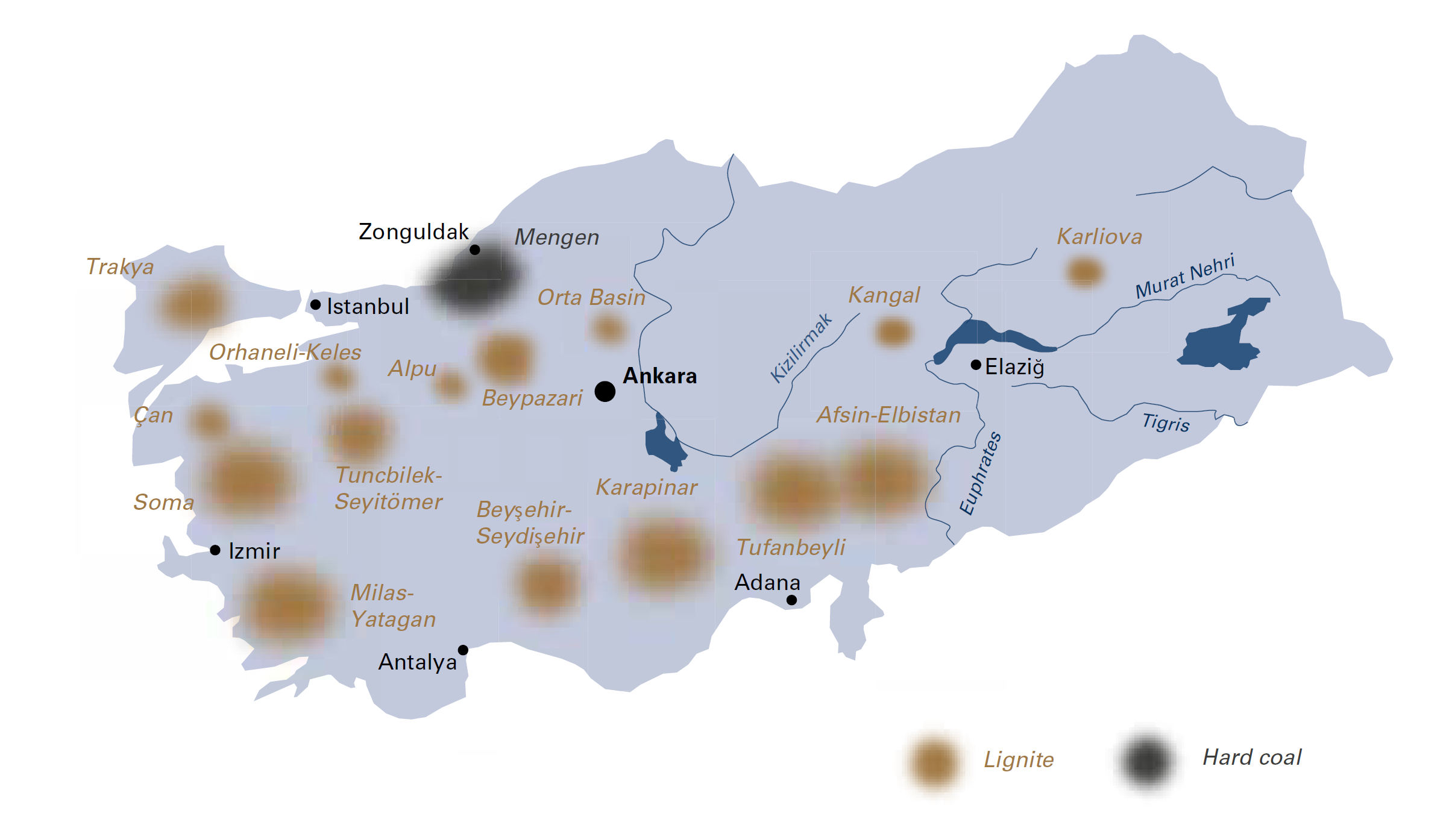

|  |  |  |
| --- | --- | --- |
| General data |  | 2018 |
| Population | million | 80.8 |
| GDP | € billion | 652.5 |
| Per capita GDP | €/person | 8 000 |

In 2017, the 1 320 MW Cenal power plant owned by CENAL ELEKTRIK was commissioned and, in 2018, the Çan-2 lignite power station was commissioned by ODAŞ GROUP at Çanakkale on the Aegean coast, site also of the 1 600 MW İÇDAŞ Bekirli power station. HİDRO-GEN ENERJI’s 510 MW Soma Kolin CFB power plant was commissioned in 2019 and construction started on EMBA ELEKTIK’s 1 320 MW Hunutlu coal power plant in Adana province which the owners in joint venture with SHANGHAI ELECTRIC POWER expect to commission in 2021. All new power plants must comply with the EU Large Combustion Plants Directive (2001/80/EC).

Turkey is also planning and constructing new coal plants to be fired by local lignite from mines in Thrace, Eskişehir, Afyonkarahisar, Kahramanmaraş, Bartin and other provinces. The planned “C” expansion of the Afşin-Elbistan power complex would make this the largest in the world. However, in 2012, the 1 200 MW Gerze power plant in Sinop province was cancelled by the ANADOLU GROUP after strong local opposition and, in February 2019, the supreme court blocked HEMA ELEKTRIK’s planned 1 320 MW coal plant at Amasra in Bartin province. Many other projects have been cancelled or delayed.

In 2018, 113.3 TWh (37.3%) of Turkey’s gross electricity production of 303.6 TWh was generated from hard coal (22.4%) and lignite (14.9%). Of the remainder, 30.4% came from fossil gas, 19.7% from hydro, 6.5% from wind, 2.5% from solar PV, 2.3% from geothermal, with smaller contributions from biofuels, waste and oil. Turkey, through its Vision 2023 strategy (*Hedef 2023*) that marks the 100th anniversary of the Republic, aims to increase its domestic electricity production by constructing more lignite-fired power plants and raising the shares of wind and geothermal power, setting a 30% capacity target for renewables. Construction of Turkey’s first nuclear power plant, a 4 800 MW Russian-built plant at Akkuyu in the south of the country, began in April 2018, while a second 4 600 MW plant is planned with Franco-Japanese technology at Sinop in the north, and a possible third plant at Igneada near Istanbul with US-Chinese technology.

The national energy and mining policy (*Milli Enerji ve Maden Politikası*), announced in April 2017 by the Minister for Energy and Natural Resources, promotes the clean and efficient use of local coal for power generation with, for example, fifteen-year purchase guarantees, capacity mechanisms and reverse auctioned feed-in tariffs. With the hashtag *#BizimKömürümüzBizimEnerjimiz* (our coal, our energy), the ministry aims by 2023 to increase coal-fired power generation capacity from 17.3 GW to 30 GW.

Turkish coal production has grown by 1.2% per year since 1990, while coal supply has grown by 3.6% per year. This reflects steadily growing lignite production, and a rapid growth in coal imports of 7.1% per year since 1990. Coal is extracted by three state-owned enterprises – TÜRKIYE KÖMÜR İŞLETMELERI (TKİ – Turkish Coal Enterprises), ELEKTRIK ÜRETIM (EÜAŞ – Electricity Generation Company) and TÜRKIYE TAŞKÖMÜRÜ KURUMU (TTK – Turkish Hard Coal Enterprises) – and a growing number of private companies, some under contract to the state-owned companies.

## Hard coal

Turkey’s main hard coal deposits are located in the Zonguldak basin, between Ereğli and Amasra on the Black Sea coast in north-western Turkey. Total hard coal resources in the basin are estimated at some 1.3 billion tonnes. The calorific value of hard coal reserves varies between 6 200 and 7 200 kcal/kg. This coal basin is the only region in Turkey where hard coal is extracted and it has a very complex geological structure which makes mechanised coal production almost impossible; hence, coal production is labour intensive and subsidised.

The state-owned TTK operates five deep mines in the Zonguldak coal basin and produced 686 thousand tonnes of saleable coal in 2018, supplying the 300 MW Catalağzı thermal power plant owned by BEREKET ENERGY and other customers. Hard coal production from private mines totalled 415 thousand tonnes.

In 2018, Turkey imported 38.3 million tonnes of hard coal for thermal power plants, steel production, industry and domestic heating purposes – half from Colombia, one third from Russia, and smaller quantities from the United States (7.0%), Australia (5.3%) and South Africa (4.2%). Coal imports are expected to continue to increase in the future.

Turkey

|  |  |  |
| --- | --- | --- |
| Coal resources and reserves |  | as at 1.1.2018 |
| Total resources hard coal | Mt | 1 338 |
| Total resources lignite | Mt | 16 259 |
| Reserves hard coal | Mt | 551 |
| Reserves lignite | Mt | 10 975 |

|  |  |  |
| --- | --- | --- |
| Primary energy production |  | 2018 |
| Total primary energy production | Mtce | 59.0 |
| Hard coal (saleable output) | Mt / Mtce | 1.1 / 1.0 |
| Lignite (saleable output) | Mt / Mtce | 85.2 / 24.3 |

|  |  |  |
| --- | --- | --- |
| Saleable coal quality |  |  |
| Hard coal net calorific value | kJ/kg | 26 000‑30 000 |
| Lignite net calorific value | kJ/kg | 8 665 |
| Hard coal ash content | % a.r. | 10.0‑15.0 |
| Lignite ash content | % a.r. | 11.0‑46.0 |
| Hard coal moisture content | % a.r. | 4.0‑14.0 |
| Lignite moisture content | % a.r. | 6.0‑55.0 |
| Hard coal sulphur content | % a.r. | 0.8‑1.0 |
| Lignite sulphur content | % a.r. | 0.2‑5.0 |

|  |  |  |
| --- | --- | --- |
| Coal imports / exports |  | 2018 |
| Hard coal imports | Mt | 38.3 |

|  |  |  |
| --- | --- | --- |
| Primary energy consumption |  | 2018 |
| Total primary energy consumption | Mtce | 208.4 |
| Hard coal consumption | Mtce | 37.0 |
| Lignite consumption | Mtce | 24.3 |

|  |  |  |
| --- | --- | --- |
| Power supply |  | 2018 |
| Total gross power generation | TWh | 303.6 |
| Net power imports (exports) | TWh | (0.6) |
| Total power consumption | est. TWh | 254.3 |
| Power generation from hard coal | TWh | 68.2 |
| Power generation from lignite | TWh | 45.1 |
| Hard coal power generation capacity | MW net | 9 600 |
| Lignite power generation capacity | MW net | 10 100 |

|  |  |  |
| --- | --- | --- |
| Employment |  | 2015 |
| Direct in hard coal mining | thousand | 14.251 |
| Direct in lignite mining | thousand | 37.596 |

## Lignite

Lignite is Turkey’s most important indigenous energy resource, with total resources of 16.3 billion tonnes of which 11.0 billion tonnes are considered economically recoverable. Deposits are spread across the country, the most important one being the Afşin-Elbistan lignite basin of south-eastern Anatolia, near the city of Maraş where deposits are up to 58 metres thick and economic reserves are estimated to be around 7 billion tonnes. The Soma basin is the second-largest lignite mining area in Turkey. Other exploited deposits are located in: Muğla province with the Yeniköy lignite facility at Ören (Milas) and the South Aegean lignite facility at Yatağan; Kütahya province with the Seyitömer lignite facility at Seyitömer and the Tunçbilek mining centre at Tavşanlı; Çanakkale province with the Çan lignite facility; Bursa province with the Bursa lignite facility at Orhaneli; and Konya province with the Ilgın lignite facility. The quality of Turkish lignite is generally very poor and only around 5.1% of existing reserves have a heat content of more than 3 000 kcal/kg (12 500 kJ/kg).

The scale of Turkey’s surface mining operations allows lignite to be produced at a relatively low cost, making it competitive with imported energy resources. In 2018, lignite output totalled a record 85.2 million tonnes, including from underground mines in the Soma, Tunçbilek and Beypazarı basins. Among the proposed new lignite mines in Turkey, those in Thrace, Eskişehir-Alpu and Afyon-Dinar would be underground; whereas those in Konya and Karamanmaraş would be opencast.

Privatisation of the Çayırhan coalfield was completed in 2017, beginning the process to privatise the five lignite fields at Trakya (Çerkezköy and Çatalca), Eskişehir Alpu, Kırklareli Vize, Afyon Dinar and Konya Karapınar. In addition, four more lignite fields, including Afşin Elbistan C-D-E, will most likely be included in the privatisation programme.

In October 2018, the Ministry of Energy and Natural Resources announced that four lignite fields had been transferred from TKİ to IMBAT MADENCILIK, FERNAS HOLDING, DEMIR EXPORT, and the construction group YAPI TEK, while three hard coalfields had been transferred from TTK to ERDEMIR MADENCILIK, TUMAS, a subsidiary of BEREKET HOLDING, and the energy company EMSA ENERJI.

Meanwhile, TKİ is working in collaboration with TÜBİTAK, the Turkish Scientific and Technical Research Council, and other international partners on research projects in the fields of lignite drying, coal gasification, coal-biomass combustion and liquid fuels production, some partly supported by the European Union.

## Asphaltite

At Silopi near the Iraqi border, the third CFB unit of CINER GROUP’s 405 MW asphaltite-fired power plant was commissioned in 2015 by CHINA NATIONAL MACHINERY ENGINEERING CORPORATION.