# Slovakia

After quickly recovering from the global economic crisis, the Slovak economy has grown strongly, by 4.1% in 2018.

The Slovak Republic does not have any significant exploitable fossil energy reserves. While the extraction of crude oil and fossil gas accounts for less than 2% of overall energy supply, there is quite a large potential for gas storage. In recent years, there has been a public debate on the exploitation of a uranium deposit at Kurišková.

At 54.7% in 2018, nuclear power has the largest share in electricity generation, followed by hydro (14.4% excluding pumped hydro). Hard coal, including coke oven gas, accounted for an estimated 5.5% of generation, lignite accounted for a further 5.7% of generation, while fossil gas (7.0%) and oil (1.5%) accounted for smaller shares. The remainder came from biofuels and waste (5.7%) and, since 2011, a steady share from solar PV (2.3%).

In the south-east of the country, the coal-fired Elektráreň Vojany I (EVO I) power plant’s 4 × 110 MW units are designed to use imported semi-anthracitic hard coal, coming now from Russia and Poland.

Two gas-fired power stations are in operation: the 350 MW Malženice CCGT commissioned in 2011 near the town of Trnava, 60 kilometres from Bratislava, and the 4 x 110 MW Vojany II or EVO II which was commissioned in 1973-74 as an oil-fired boiler plant, but converted to gas soon after.

Given the need for long-term, low-carbon strategies under the Paris Agreement, the Slovak Republic is preparing, in co‑operation with the World Bank, a low-carbon development strategy to 2050. The national energy policy, approved in November 2014, signals measures to reduce end-user electricity prices, including the phasing out of tariffs for renewable electricity by 2020. The policy is to focus on the use of renewable energy sources for heat, electricity and transport, and encourage heat and power co‑generation.

Overall, the energy mix under the national energy policy is well-balanced, with support for indigenous lignite and renewables. Given the high share of nuclear in its power generation mix, Slovakia’s dependency on imported energy sources in 2017 (64.8%) is only slightly above the EU average, despite an almost total dependency on imported oil and gas.

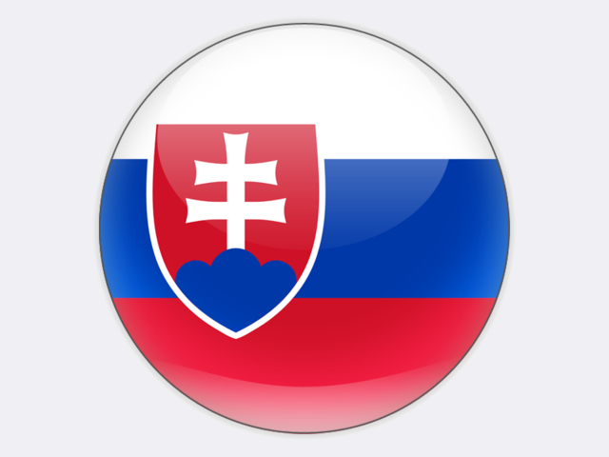

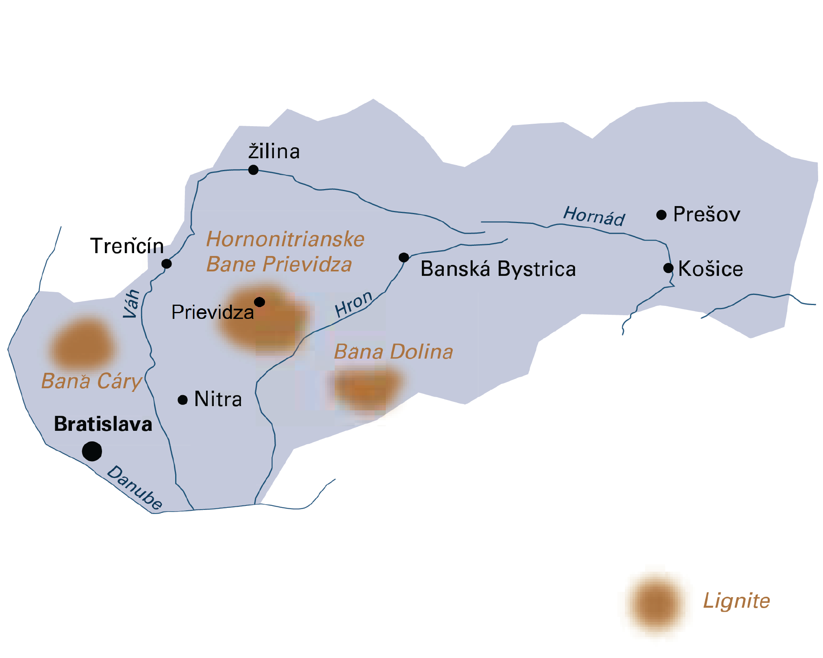

|  |  |  |
| --- | --- | --- |
| General data |  | 2018 |
| Population | million | 5.4 |
| GDP | € billion | 90.2 |
| Per capita GDP | €/person | 16 600 |

## Lignite

Lignite resources are estimated at just over one billion tonnes. Exploitable lignite reserves, including brown coal, are calculated at 135 million tonnes. There is an insignificant hard coal deposit in the eastern part of Slovakia, which is not exploitable.

In 2018, 1.5 million tonnes of lignite were produced. Lignite is extracted by one company at three underground mines located in the central and western parts of Slovakia. More than 90% of the total lignite production was used for electricity generation and district heating.

HORNONITRIANSKE BANE PRIEVIDZA (HBP) is a private coal mining company with a history of over one hundred years. Seated in the town of Prievidza, HBP extracts lignite at the Cigeľ-Handlová and Nováky deposits located in the Horná Nitra region in central Slovakia and at the Čary deposit located in western Slovakia. In the past, there were

three independent collieries in operation in Horna Nitra – Cigeľ, Handlová and Nováky – which were integrated into HBP. Cigeľ colliery was closed in October 2017. The depth of the worked coal seams ranges from 150 metres to 450 metres.

The lignite seams have a thickness of up to 20 metres and are mostly extracted using a long-wall, top-coal caving (LTCC) method. Thin seams, of around 4 metres, are extracted with conventional longwalls. HBP also operates a mines rescue station which serves all mining districts in Slovakia. All lignite is supplied to the nearby 486 MW Nováky power plant (Elektráreň Nováky – ENO) belonging to the SLOVENSKÉ ELEKTRÁRNE COMPANY which is 50% owned by ENEL of Italy and 50% by EPH of the Czech Republic. Nearly one third of the lignite supplied in 2018 came from mines in the Nováky deposit.

BAŇA DOLINA COMPANY, near the town of Veľký Krtíš, extracted lignite from the Modrý Kameň deposit in southern Slovakia at a depth of 150 metres. Lignite was supplied to the ENO power station. The mine was closed in May 2015.

The BAŇA ČÁRY COMPANY, near the town of Holíč in western Slovakia, extracts around 170 thousand tonnes of lignite each year from a working depth of 180 metres. The mine plans to expand its annual production to reach 350 thousand to 500 thousand tonnes.

BANSKÁ MECHANIZÁCIA A ELEKTRIFIKÁCIA NOVÁKY (BME) is a modern mining equipment supplier owned by HBP that designs and manufactures high-pressure hydraulic roof supports suitable for LTCC mining. BME also produces other mining and construction machinery, as well as equipment for the transport sector.

Together with SLOVENSKÉ ELEKTRÁRNE and ENEL, HBP is actively engaged with modernising the coal-fired ENO power plant at Nováky. In May 2015, work began on a de‑NOx system for two of the 110 MW blocks at the plant. The flue gas desulphurisation and particulate filtration systems were also renewed. HBP also has an interest in research and works with universities on various projects mostly on the non-energetic use of Čary lignite and on the accumulated water in surface swamps and wetlands found in surface depressions.

Slovakia

|  |  |  |
| --- | --- | --- |
| Coal resources and reserves |  | as at 1.1.2018 |
| Total resources hard coal | Mt | 19 |
| Total resources lignite | Mt | 1 073 |
| Reserves hard coal | Mt | 0 |
| Reserves lignite | Mt | 135 |

|  |  |  |
| --- | --- | --- |
| Primary energy production |  | 2018 |
| Total primary energy production | Mtce | 9.0 |
| Lignite (saleable output) | Mt / Mtce | 1.5 / 0.5 |

|  |  |  |
| --- | --- | --- |
| Saleable coal quality |  |  |
| Lignite net calorific value | kJ/kg | 10 450 |
| Lignite ash content | % a.r. | <25 |
| Lignite moisture content | % a.r. | <35 |
| Lignite sulphur content | % a.r. | <2.5 |

|  |  |  |
| --- | --- | --- |
| Coal imports / exports |  | 2018 |
| Hard coal imports | Mt | 3.8 |
| Lignite imports | Mt | 0.6 |

|  |  |  |
| --- | --- | --- |
| Primary energy consumption |  | 2018 |
| Total primary energy consumption | Mtce | 24.7 |
| Lignite consumption | Mtce | 0.8 |

|  |  |  |
| --- | --- | --- |
| Power supply |  | 2018 |
| Total gross power generation | TWh | 27.2 |
| Net power imports (exports) | TWh | 3.8 |
| Total power consumption | TWh | 31.0 |
| Power generation from hard coal | TWh | 1.5 |
| Power generation from lignite | TWh | 1.4 |
| Hard coal power generation capacity | MW | 440 |
| Lignite power generation capacity | MW | 486 |

|  |  |  |
| --- | --- | --- |
| Employment |  | 2018 |
| Direct in lignite mining | thousand | 2.000 |
| Other lignite-related* | thousand | 0.430 |

* e.g. in power generation, equipment supply, services and R&D