# Slovenia

Since its foundation in 1991, the Republic of Slovenia has enjoyed steady economic growth. After a period of strong growth since 2014, the economy slowed in 2019. The country’s primary energy consumption increased by 40% between 2000 and 2008, reaching a peak of 11.1 Mtce. In 2018, consumption was 9.8 Mtce.

Resources of lignite and brown coal in Slovenia are estimated to be 1 256 million tonnes, lying at Velenje (358 million tonnes), Zasavje (68 million tonnes) and Goričko (830 million tonnes), with mineable reserves accounting for 109 million tonnes. Approximately 47% of the country’s primary energy requirements are met by imports. Indigenous lignite production accounted for approximately 13.1% of primary energy supply in 2018, with imported coal bringing coal’s total share to 16.3%. Oil had a share of 34.3%, nuclear 21.7%, biofuels and waste 10.2%, fossil gas 10.5%, hydro 5.8% and the remaining 1.2% came from renewable energy sources.

The key elements of Slovenian energy policy are closely aligned with the priorities of the European Union, such as a national plan for renewables and a plan to improve energy efficiency. In the area of climate policy, Slovenia adopted a strategic framework for climate change adaptation in December 2016. In the long term, coal and lignite are expected to be partially replaced by renewable energy sources and coal imports will reduce. PREMOGOVNIK VELENJE will continue its lignite production until 2054 under currently valid plans as lignite is needed in the currently well-balanced energy mix for security of supply reasons.

At 35.9% in 2018, nuclear power accounted for the largest share of electricity generation in Slovenia, followed by hydro (29.2%) and coal and lignite (28.7%). Other sources had rather small shares, for example: fossil gas (2.9%), biofuels and waste (1.7%) and solar (1.6%).

## Lignite

Only one lignite deposit is exploited in Slovenia, at Velenje in the north of the country. In 2018, 3.2 million tonnes of lignite were produced. Velenje mine is the only coal mine in Slovenia and all of its lignite output is used at the nearby Šoštanj power plant. Operated by PREMOGOVNIK VELENJE and employing a unique mining method, it is one of the largest and most modern underground mines in Europe. The mine is located in the Šaleška dolina valley and boasts one of the thickest-known lignite seams in the world, at more than 160 metres.

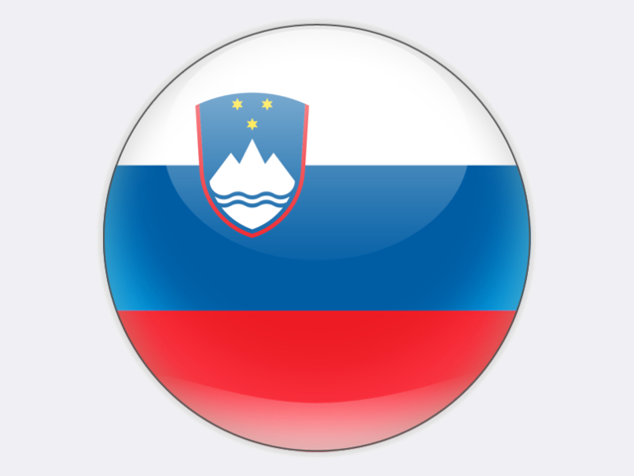

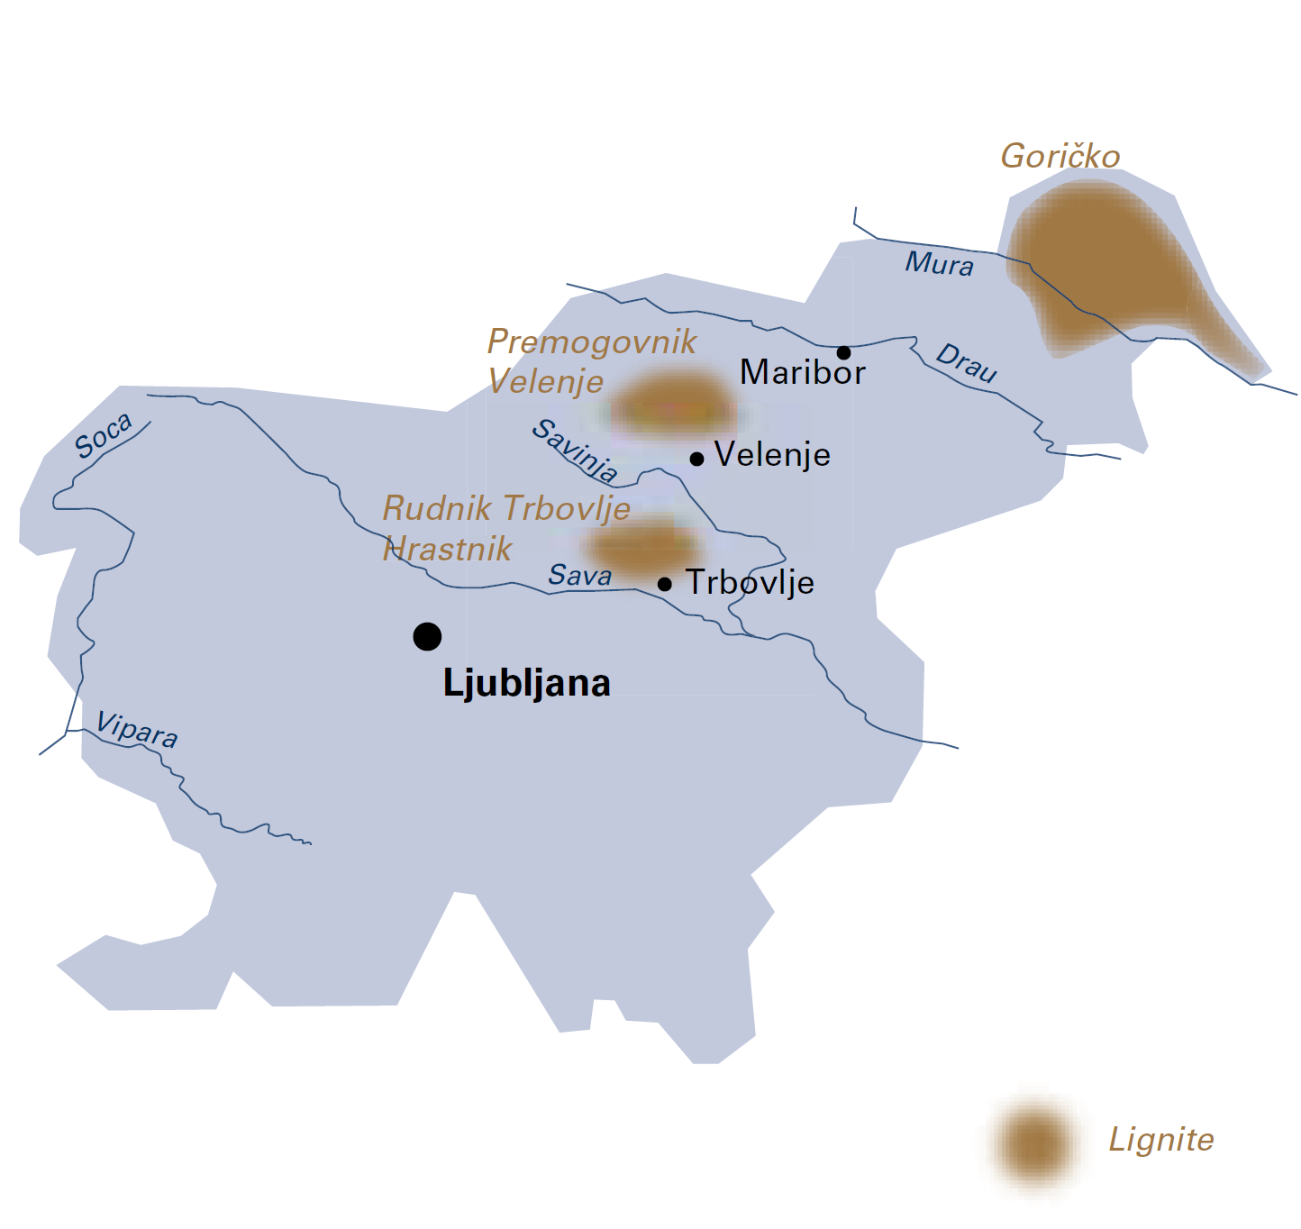

|  |  |  |
| --- | --- | --- |
| General data |  | 2018 |
| Population | million | 2.1 |
| GDP | € billion | 45.8 |
| Per capita GDP | €/person | 22 100 |

The company’s long-term strategy is to operate the mine until 2054, as it is likely to remain Slovenia’s only exploitable energy resource. The Velenje coal mine belongs to the state-owned HOLDING SLOVENSKE ELEKTRARNE (HSE) who also owns the 1 029 MW Šoštanj (TEŠ) thermal power plant as well as hydro power plants.

Imported coal is mostly used at ENERGETIKA LJUBLJANA’s Termoelektrarna Toplarna Ljubljana (TE-TOL) heat and power plant in Ljubljana. The company covers over 74% of the capital’s household demand for gas and heat.

Taking into consideration the increasing demand for electricity, the risks of energy import dependence and the abundant coal reserves at Velenje, HSE commissioned a new 600 MW unit at Šoštanj thermal power plant in 2015. Unit 6 uses the best available techniques (BAT) to achieve an efficiency of more than 43% and deliver CO2 emission reductions of 35%, as older units are replaced. The new unit has had a significant economic and environmental impact in Slovenia by ensuring stable electricity prices and lower emissions.

PREMOGOVNIK VELENJE is a technologically well-developed and strongly integrated company with over 144 years in lignite mining. In 2007, the company received a special award from the Slovenian Chamber of Engineers for its innovative approach to mining engineering.

The “Velenje mining method” is performed by top caving hanging seams. The very first long-wall faces appeared in 1947, quickly followed by the extensive introduction of long-wall faces in 1952. The basic approach is to extend the lignite extraction area above the protected area at the face. The “Velenje mining method” has been proven to be the most effective method for extracting thick coal seams. PREMOGOVNIK VELENJE continues to develop this method in order to gain even more improvements.

The knowledge and products of PREMOGOVNIK VELENJE offer excellent opportunities for co-operation with other countries, particularly where there is a need to introduce new technologies in Europe (*e.g.* in Bosnia and Herzegovina, North Macedonia, Montenegro, Serbia, Slovakia and Turkey) and further away in the Asia-Pacific region.

PREMOGOVNIK VELENJE is also a partner in many EU-funded research and innovation projects which aim to develop clean coal technologies and safer mining solutions, as well as methods for predicting gas and rock outbursts and gas emissions from thick coal seams.

PREMOGOVNIK VELENJE has always aimed to prevent and eliminate any negative environmental impacts of its operations and has played an active role in land rehabilitation and air/water protection programmes in the Šaleška dolina valley. The company regularly monitors its environmental impacts, but the clearest testament to sustainable development is the tourist and sports resort that has been developed around the man-made lakes above the Velenje coal mine.

The energy transition brings new challenges in Slovenia and elsewhere. As recognised in the “Clean energy for all Europeans” package of legislation tabled in November 2016, a just transition should be ensured in those regions affected by structural change brought about by any reductions in coal mining or coal-fired power generation. There is no clear decision for a coal phase-out in Slovenia, but the question will certainly be addressed as emission reduction targets are set in upcoming strategic documents to be adopted by the government in 2020, including a new *Energy Concept for Slovenia*. In any event, Slovenia and PREMOGOVNIK VELENJE are actively involved in the Coal Regions in Transition Platform initiative of the European Commission as all stakeholders strive to address the challenges of the future energy transition.

Slovenia

|  |  |  |
| --- | --- | --- |
| Coal resources and reserves |  | as at 1.1.2019 |
| Total resources lignite | Mt | 1 256 |
| Reserves lignite | Mt | 109 |

|  |  |  |
| --- | --- | --- |
| Primary energy production |  | 2018 |
| Total primary energy production | Mtce | 5.0 |
| Lignite (saleable output) | Mt / Mtce | 3.2 / 1.3 |

|  |  |  |
| --- | --- | --- |
| Saleable coal quality |  |  |
| Lignite net calorific value | kJ/kg | 10 650 |
| Lignite ash content | % a.r. | 16 |
| Lignite moisture content | % a.r. | 35 |
| Lignite sulphur content | % a.r. | 1.6 |

|  |  |  |
| --- | --- | --- |
| Coal imports / exports |  | 2018 |
| Hard coal imports | Mt | 0.4 |

|  |  |  |
| --- | --- | --- |
| Primary energy consumption |  | 2018 |
| Total primary energy consumption | Mtce | 9.8 |
| Lignite consumption | Mtce | 1.3 |

|  |  |  |
| --- | --- | --- |
| Power supply |  | 2018 |
| Total gross power generation | TWh | 16.3 |
| Net power imports (exports) | TWh | (0.5) |
| Total power consumption | TWh | 13.8 |
| Power generation from lignite | TWh net | 3.8 |
| Lignite power generation capacity | MW | 1 029 |

|  |  |  |
| --- | --- | --- |
| Employment |  | 2018 |
| Direct in lignite mining | thousand | 1.252 |
| Other lignite-related* | thousand | 2.371 |

* e.g. in power generation, equipment supply, services and R&D