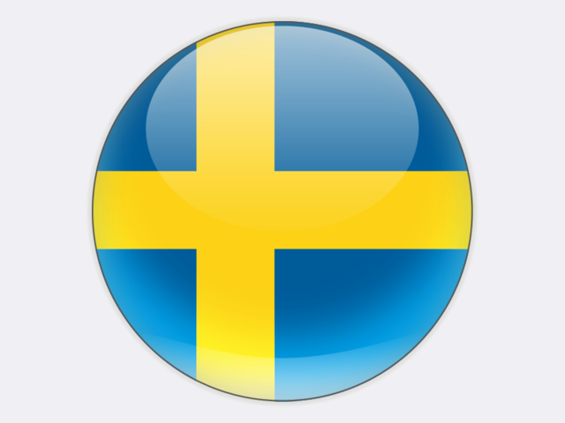

## Sweden

There is currently no coal mining in Sweden and imported coal accounted for only 4.6% of the country’s primary energy supply in 2018. Coal reserves and resources are estimated at 5 million tonnes in southern Sweden. In 2018, 540 thousand tonnes of peat were extracted.

Since the mid-1990s, coal imports have been stable at close to 3 million tonnes per year (2.7 million tonnes in 2018). Demand for high-quality coking coal from Australia and the United States comes mainly from Sweden’s speciality steel industry. Limited quantities of steam coal, mostly imported from Russia, are used at cement works and at combined heat and power plants which are fuelled mainly with solid biofuels, including at the FORTUM / STOCKHOLM EXERGI Värtan plant in Stockholm. Coal was used in the pulp and paper industry, but has been replaced with biofuels.

In 2018, nuclear power accounted for 41.3% of Sweden’s gross electricity production, while the share of hydro power was 38.7%. The balance was met by wind power (10.4%) and CHP plants firing mainly solid biofuels and wastes (7.5%), and fossil fuels (1.9%). Wind and biomass are generously subsidised while nuclear and fossil fuels are heavily taxed.

The role of nuclear power has long been the subject of political debate in Sweden. In June 2010, the parliament agreed that new nuclear power plants could replace old ones at existing sites. After lengthy negotiations, this policy was restated in a cross-party framework agreement of June 2016.

A new Climate Act entered into force on 1 January 2018 with the aim of linking Sweden’s annual Budget Bill with climate objectives. An independent climate policy council will hold the government to account. In June 2018, the Energy Bill adopted by parliament includes a 100% target for renewable electricity production by 2040. In response to such political developments, the owners of the Värtan CHP plant have decided to phase out coal use by 2022.