# Serbia

At the heart of the Balkans, Serbia is well located for services and trade: the Morava Valley is the easiest land route from Europe to Turkey and beyond. Economic growth in 2018 was a healthy 4.3% and annual GDP *per capita* stood at €12 300 on a purchasing power parity basis.

Serbia has very substantial lignite resources which are easily accessible for exploitation. Its lignite reserves are estimated to be over 7 billion tonnes; in Europe, only Germany and Turkey have larger reserves. Serbia relies on lignite and small quantities of imported coal for one half of its total primary energy supply. For electricity generation, the share of lignite was 71.0% in 2018 with hydro (26.3%) accounting for most of the remainder, while fossil gas (0.5%) and wind (0.3%) made only very small contributions. According to the Serbian energy strategy, coal will remain the country’s main source of energy.

The 100% state-owned ELEKTROPRIVREDA SRBIJE (EPS) or Electric Power Industry of Serbia is a vertically integrated utility company with two subsidiaries: EPS Distribution LLC Belgrade and EPS Trading LLC Ljubljana. EPS has eight divisions for electricity and coal production, including electricity supply which is the company’s main activity. The production, processing and transport of coal, electricity generation and distribution, including distribution system operator, renewable energy production, and the raising of steam and hot water in cogeneration plants are all performed by EPS. Since June 1999, EPS has not been able to operate its facilities in Kosovo and Metohija.

With 29 153 employees, excluding workers from Kosovo, and about 3.5 million consumers, EPS is the largest company in Serbia. The installed capacity of EPS power plants totals 7 401 MW: lignite-fired power plants 4 079 MW; gas- and oil-fired combined heat and power plants 336 MWe / 505 MWth; and hydro power plants 2 986 MW.

Investment in new renewable energy sources is growing. In May 2019, the 158 MW Čibuk 1 wind farm became operational, 60 kilometres from Belgrade. This was followed, in August 2019, by the commissioning of the 104.5 MW Kovačica wind farm, located 70 kilometres from the capital and partly financed by the European Bank for Reconstruction and Development. In the Kostolac lignite basin, another project is nearing completion: the 66 MW Kostolac wind farm, a €100 million investment partly financed by the German KfW Bank.

In order to increase the efficiency of the power sector through market mechanisms, the Serbian government has gradually introduced competition since adoption of the Law on Energy in 2004. Opening of the electricity market will continue until it is fully opened in line with the country’s ratification of the Energy Community Treaty.

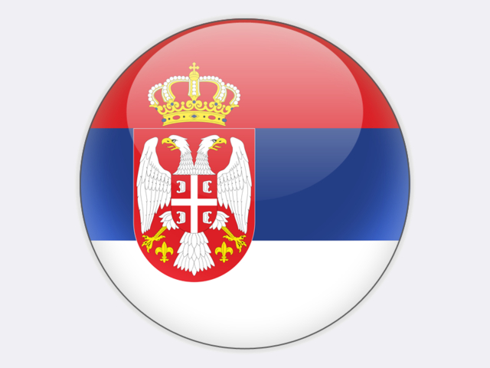

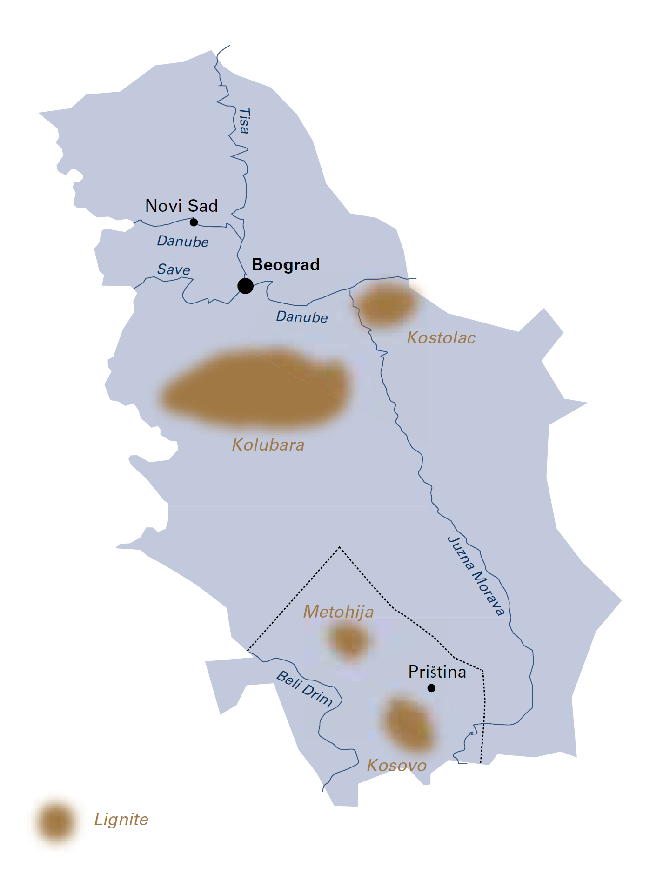

|  |  |  |
| --- | --- | --- |
| General data |  | 2018 |
| Population | million | 7.0 |
| GDP | € billion | 42.9 |
| Per capita GDP | €/person | 6 100 |

## Lignite

Production of lignite, with an average calorific value of 7 850 kJ/kg, takes places at open-pit and underground mines in the Kolubara and Kostolac coal basins.

The 600 square kilometre Kolubara coal basin is located in the western part of Šumadija, between Rudovci to the east, Koceljeva to the west, Stepojevac to the north and Slovac to the south. There, Field B/C, Field D, Tamnava-West Field and Field G open-pit mines account for around 75% of Serbian lignite production. Lignite is supplied by rail to the Kolubara thermal power plant (TPP) at Veliki Crljeni, TPP Nikola Tesla A and B at Obrenovac about 40 kilometres from the mines, and TPP Morava at Svilajnac. Together, these three thermal power plants comprise fourteen units with a total capacity of 3 141 MW. Lignite from all four open-pit mines is processed in coal preparation plants at Vreoci and the Tamnava-West Field mine.

In the Kolubara coal basin, preparatory works are in progress to develop open-pit mine Field E, with 400 million tonnes of lignite reserves, as a replacement for Field D. The mine’s planned annual output is 12 million tonnes. Field G open pit mine extension was opened in 2017 with 36.5 million tonnes of good quality lignite reserves. In 2019, the new open-pit Radljevo mine with 350 million tonnes of lignite reserves was officially opened after many months of overburden removal. The mine’s annual output will be 13 million tonnes of lignite. The relocation of infrastructure to serve these new mines in the Kolubara basin was completed early in 2019.

Lignite mined in the Kostolac basin, from the 50 square kilometre Drmno coal deposit in the eastern part of the basin, accounts for the remaining 25% of Serbian lignite production and is supplied to the TPP Kostolac A and B power plant (310 MW and 700 MW).

In 2018, EPS extracted 38.0 million tonnes of lignite in the Kolubara and Kostolac basins, with overburden-to-production ratios of 2.5 cubic metres per tonne in Kolubara and 4.5 cubic metres per tonne in Kostolac. In addition, EPS purchased coal from underground mines operated by state-owned PEU “Resavica”. The closure of two of these mines was announced in 2018.

In December 2014, a loan agreement was signed by the Serbian government with the EXIM BANK OF CHINA for a $715.6 million project to build a new 350 MW unit (B3) at TPP Kostolac and to extend the annual capacity of Drmno mine from 9 million tonnes to 12 million tonnes of lignite. Construction is in progress and the new unit is planned to be operational by the end of 2021. Unit B3 of TPP Kostolac will help stabilise Serbia’s energy system while respecting European Union environmental standards.

Environmental protection is a business priority for EPS, this being in line with the Serbian government’s policy to join the European Union and the country’s commitments under the Energy Community Treaty. Since 2015, EPS has harmonised the operation of its facilities with the EU *acquis*.

From 2016 to 2019, EPS has invested about €320 million in production modernisation and environmental protection projects, particularly at its thermal power plants where flue gas desulphurisation, electrostatic filters, ash and slag transport, and wastewater treatment projects have been completed. By the end of 2025, EPS plans to have invested more than €850 million in its facilities in order to improve efficiency and environmental protection. About €650 million will be invested in air pollution control equipment to further reduce emissions of sulphur dioxide, oxides of nitrogen and fine particulates.

Serbia

|  |  |  |
| --- | --- | --- |
| Coal resources and reserves |  | as at 1.1.2018 |
| Total resources hard coal | Mt | 855 |
| Total resources lignite | Mt | 20 186 |
| Reserves hard coal | Mt | 402 |
| Reserves lignite | Mt | 7 112 |

|  |  |  |
| --- | --- | --- |
| Primary energy production |  | 2018 |
| Total primary energy production* | Mtce | 15.0 |
| Lignite (saleable output) | Mt / Mtce | 38.0 / 9.8 |

|  |  |  |
| --- | --- | --- |
| Saleable coal quality |  |  |
| Hard coal net calorific value | kJ/kg | 12 000‑18 000 |
| Lignite net calorific value | kJ/kg | 7 500‑8 200 |
| Hard coal ash content | % a.r. | 12.0‑35.0 |
| Lignite ash content | % a.r. | 14.0‑18.0 |
| Hard coal moisture content | % a.r. | 45.0‑54.0 |
| Lignite moisture content | % a.r. | 48.0‑52.0 |
| Hard coal sulphur content | % a.r. | 0.9‑3.8 |
| Lignite sulphur content | % a.r. | 0.4‑0.9 |

|  |  |  |
| --- | --- | --- |
| Coal imports / exports |  | 2018 |
| Hard coal imports | Mt | 0.1 |
| Lignite imports | Mt | 0.5 |

|  |  |  |
| --- | --- | --- |
| Primary energy consumption |  | 2017 |
| Total primary energy consumption | Mtce | 22.3 |
| Hard coal consumption | Mtce | 0.1 |
| Lignite consumption | Mtce | 10.5 |

|  |  |  |
| --- | --- | --- |
| Power supply |  | 2018 |
| Total gross power generation | TWh | 39.6 |
| Net power imports (exports) | TWh | 0.6 |
| Total power consumption | TWh | 40.2 |
| Power generation from lignite | TWh | 28.1 |
| Lignite power generation capacity | MW | 5 314 |

|  |  |  |
| --- | --- | --- |
| Employment |  | 2018 |
| Direct in underground coal mining | thousand | 3.500 |
| Direct in lignite mining and power | thousand | 14.850 |

* 2017 data