# Romania

Romania enjoyed solid economic growth of 4.1% in 2018 and a low unemployment rate of 4.2%, thanks mainly to its manufacturing sector. The country has significant energy resources, including coal, fossil gas and oil. Over three quarters of the country’s total primary energy supply is met from indigenous resources, well above the EU average of 45%. Coal and lignite account for 16.2% of energy supply, this being slightly above the EU average.

Hard coal resources are estimated at 2 446 million tonnes of which 11 million tonnes might be economically recoverable. Proven reserves of lignite total 280 million tonnes, within 9 640 million tonnes of resources. Of these, 95% lie in the Oltenia mining basin where more than 80% can be surface mined. The remaining lignite deposits have low economic potential and so extraction in most other areas has stopped. The country has a long coal mining tradition, stretching back over 150 years. Romania’s entire hard coal and lignite output is used for heat and power generation.

The total net capacity of installed generation was 19 766 MW in 2018: coal 4 373 MW (22.1%), fossil gas / fuel oil 3 404 MW (17.2%), hydro 6 329 MW (32.0%), nuclear 1 300 MW (6.6%) and renewables 4 360 MW (22.1%), mostly wind turbines and solar PV. Peak demand in 2018 was 8 920 MW on 27 February, indicating a generation overcapacity and thus the opportunity for electricity exports.

In 2017, gross electricity production in Romania was 64.3 TWh: 26.2% from coal, 23.1% from hydro, 17.9% from nuclear, 16.6% from fossil gas and 15.2% renewables. Net electricity exports were 2.9 TWh in 2017 and 2.5 TWh in 2018. Exports have collapsed in 2019 and imports rose, making Romania a net importer; the additional cost of allowances under the EU emissions trading system (ETS) has made non-EU power generation more competitive.

Romania’s first commercial nuclear reactor began operating in 1996 and a second CANDU reactor was commissioned in May 2007, thus completing two of the five reactors whose construction began in the 1980s and bringing the total gross capacity at the Cernavodă nuclear power plant to 1 413 MW. The completion of two further 720 MW reactors is planned by SOCIETATEA NATIONALA NUCLEARELECTRICA (SNN). It is a government priority to progress these reactors.

Romania has established an energy policy framework which is in line with EU law, regulating the production of gas, coal, lignite, oil and nuclear energy, as well as power plant modernisation. Indeed, by 2030, Romania plans to replace those older power plants reaching the end of their lives with new, high-efficiency, low-emission power plants.



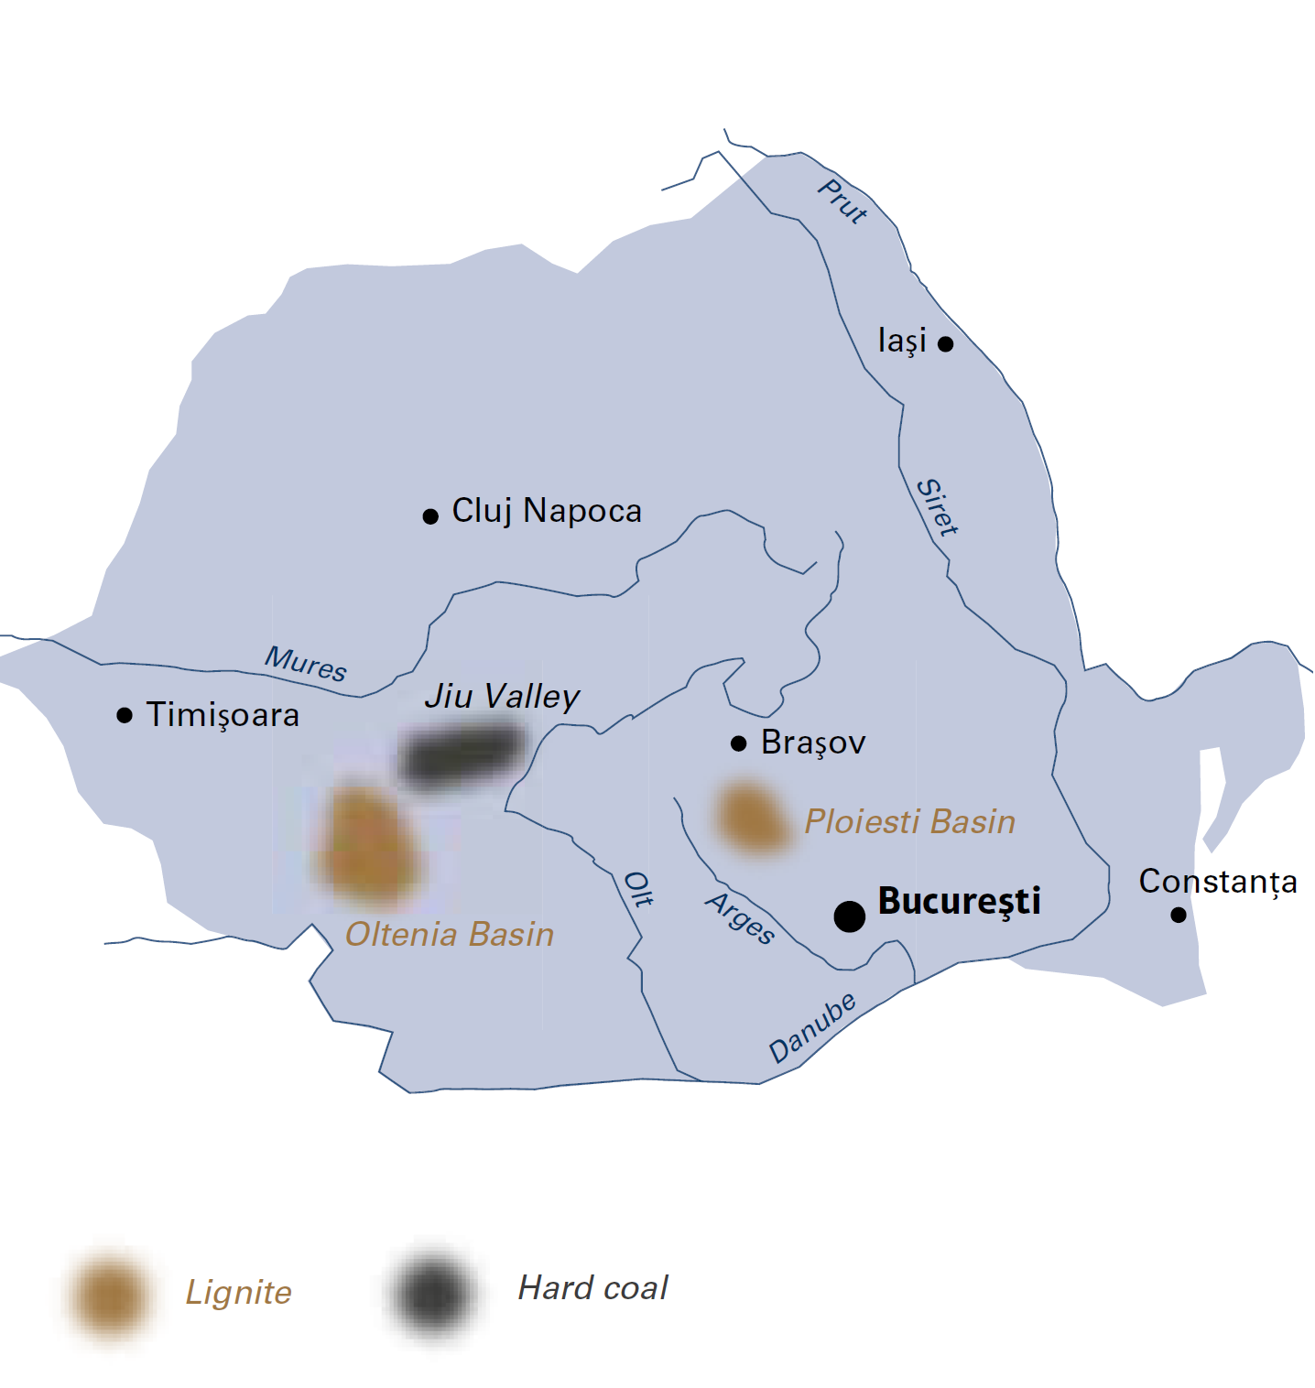

|  |  |  |
| --- | --- | --- |
| General data |  | 2018 |
| Population | million | 19.5 |
| GDP | € billion | 202.9 |
| Per capita GDP | €/person | 10 400 |

The Romanian government published its *Energy Strategy 2019-2030* in November 2018, including a perspective to 2050. A priority of the strategy is to maintain the current level of diversity of indigenous energy sources. To that end, the government will stimulate investment in oil, fossil gas and lignite exploitation. Romania is also considering the development of a national gas transmission system along the Bulgaria-Romania-Hungary-Austria (BRUA) corridor and the development, on Romanian territory, of the Southern Transmission Corridor for Black Sea gas.

## Lignite

COMPLEXUL ENERGETIC OLTENIA (CEO) or Oltenia Energy Complex is Romania’s largest producer of coal-based energy with an installed gross capacity of 3 240 MW. The company is responsible for 99% of national lignite production. Its mines and power plants provide direct jobs for 13 000 people.

Lignite mining offers Romania a competitive advantage with the use of modern technologies and skilled labour to provide low-cost, base-load electricity. Reserves of lignite are concentrated in a relatively small area of 250 square kilometres where lignite is mined in twelve opencast pits licensed for another fifty years. These reserves provide a long-term, secure supply for the adjacent Turceni (1 320 MW) and Rovinari (990 MW) power plants. Further to the south lie the 300 MW Craiova and 630 MW Ișalnița power plants, also lignite-fired.

Since January 2017, the price of CO2 emission allowances under the EU emissions trading system (ETS) has imposed an unbearable financial burden on CEO. In 2018, the company reported a loss of around €230 million, mainly due to its obligation to acquire CO2 allowances. These now account for half of its total operating costs, so more than fuel and labour costs combined. The company has been forced to take out loans for the purchase of allowances. This is clearly an unsustainable economic situation for a country which depends on electricity from lignite-fired power plants.

Negotiations between CEO and CHINA HUADIAN ENGINEERING COMPANY to develop a new 600 MW lignite-fired unit that will replace some existing older units are currently ongoing.

## Hard coal

The COMPLEXUL ENERGETIC HUNEDOARA (CEH) or Hunedoara Energy Complex is a state-owned electricity and heat producer headquartered at Petroşani in the Southern Carpathians. It owns and operates four underground hard coal mines in the Jiu Valley (Lonea, Livezeni, Vulcan and Lupeni) and two coal-fired power plants, as well as the Prestserv mines rescue station. The company accounts for less than 2% of Romanian electricity generation, with a gross capacity of 1 225 MW and 3 022 employees in 2018.

The main consumers of hard coal are CEH’s two thermal power plants at Paroşeni (150 MW) and Mintia-Deva (1 075 MW). Indigenous hard coal production has the advantage of ensuring a long-term supply for these power plants. However, hard coal mining in Romania faces complex geological conditions, making profitable mining difficult. Petrila mine closed in 2015, followed in 2017 by Paroşeni and Uricani mines.

In April 2018, the Romanian government adopted an emergency ordinance requiring CEH to provide 400 MW of system services over the two-year period to 2020 under a Service of General Economic Interest (SGEI) exemption.

In November 2018, the European Commission found that CEH had received around €60 million of incompatible state aid through four repayable public loans. These had funded the temporary rescue aid approved in April 2015 by the European Commission (C(2015) 2652) with a view to securing the company’s long-term economic viability according to Council Decision 787/2010/EU.

Romania

|  |  |  |
| --- | --- | --- |
| Coal resources and reserves |  | as at 1.1.2018 |
| Total resources hard coal | Mt | 2 446 |
| Total resources lignite | Mt | 9 920 |
| Reserves hard coal | Mt | 11 |
| Reserves lignite | Mt | 280 |

|  |  |  |
| --- | --- | --- |
| Primary energy production |  | 2018 |
| Total primary energy production* | Mtce | 36.4 |
| Hard coal (saleable output) | Mt / Mtce | 0.7 / 0.4 |
| Lignite (saleable output) | Mt / Mtce | 23.5 / 5.6 |

|  |  |  |
| --- | --- | --- |
| Saleable coal quality |  |  |
| Hard coal net calorific value | kJ/kg | 14 200‑15 900 |
| Lignite net calorific value | kJ/kg | 7 200‑8 200 |
| Hard coal ash content | % a.r. | 37‑44 |
| Lignite ash content | % a.r. | 30‑36 |
| Hard coal moisture content | % a.r. | 5.0‑7.4 |
| Lignite moisture content | % a.r. | 40‑43 |
| Hard coal sulphur content | % a.r. | 0.5‑1.8 |
| Lignite sulphur content | % a.r. | 1.0‑1.5 |

|  |  |  |
| --- | --- | --- |
| Coal imports / exports |  | 2018 |
| Coal imports | Mt | 0.9 |
| Coal exports | Mt | 0.0 |

|  |  |  |
| --- | --- | --- |
| Primary energy consumption |  | 2017 |
| Total primary energy consumption | Mtce | 47.6 |
| Hard coal consumption | Mtce | 1.2 |
| Lignite consumption | Mtce | 5.6 |

|  |  |  |
| --- | --- | --- |
| Power supply |  | 2017 |
| Total gross power generation | TWh | 64.3 |
| Net power imports (exports) | TWh | (2.9) |
| Total power supply | TWh | 56.0 |
| Power generation from hard coal | TWh | 1.2 |
| Power generation from lignite | TWh | 15.6 |
| Hard coal power generation capacity | MW gross | 1 225 |
| Lignite power generation capacity | MW gross | 3 240 |

|  |  |  |
| --- | --- | --- |
| Employment |  | 2018 |
| Direct in hard coal mining | thousand | 3.022 |
| Direct in lignite mining and generation | thousand | 13.000 |

* 2017 data

At the end of October 2019 and in the absence of any viable restructuring plan, CEH again filed for insolvency, having reported losses of €56 million for the first half year and total debts of over €0.5 billion.