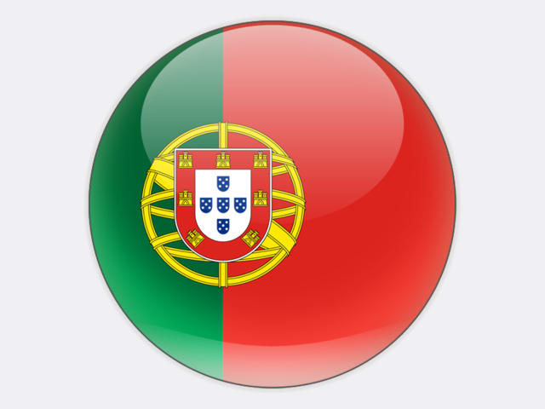

## Portugal

Portugal has limited indigenous energy resources, leading to a 79.9% energy-import dependence in 2017. Its last coal mine, Germunde in the Castelo de Paiva region, was closed in 1994, leaving behind national reserves of 3 million tonnes. The country also has lignite resources of 66 million tonnes.

In 2018, 51.1% of Portugal’s electricity production came from renewable energy sources: hydro, wind, biofuels, solar PV, geothermal and wave. Nevertheless, conventional thermal power generation remains crucial to cover those periods when wind power is not available and to balance the annual variations in hydro power production on the Iberian Peninsula. Coal-, oil- and gas-fired power generation together accounted for 48.0% of gross electricity production in 2018. Coal’s share of gross production was 20.2%.

Imported coal accounted for 12.4% of total primary energy supply in 2018 with imports of 4.7 million tonnes coming from Colombia and the United States. Most of this coal was consumed at Portugal’s two coal-fired power plants located at Sines (1 256 MW) and Pego (628 MW). Both are fitted with flue gas desulphurisation and selective catalytic reduction to reduce emissions of sulphur dioxide and NOx.

Sines power plant, adjacent to a coal import terminal on the Atlantic coast, was built in the late 1980s and is owned by ENERGIAS DE PORTUGAL (EDP). The inland Pego power plant, about 120 kilometres north-west of Lisbon, was fully commissioned in 1995 and is now owned by TRUST ENERGY, a 50%-50% joint venture between ENGIE and MARUBENI. Around 650 are employed at the two power plants and the coal port.

In November 2017, the Portuguese Government announced its commitment to retire all coal-fired power plants by 2030. Since 1 January 2018, coal used to produce electricity in Portugal has been taxed at a rate corresponding to 10% of the tax on petroleum and energy products, plus a carbon tax corresponding to 10% of the additional levy on CO2 emissions. These rates will be increased each year to reach 100% in 2022.