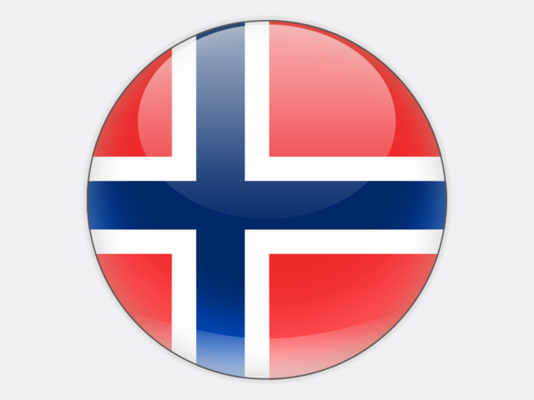

## Norway

Norway, Europe’s northernmost country, opted to stay out of the European Union by referendum in 1994, but supplies significant volumes of oil and fossil gas to the Union. In 2017, 25.3% of EU gas imports came from Norway which is the world’s third largest gas exporter after Russia and Qatar. Hydro power plants supplied 95.0% of Norway’s gross electricity generation in 2018 and the country is a significant net exporter of electricity: 6.9% of gross production.

In 2018, Norway produced 145 thousand tonnes of hard coal and imported 746 thousand tonnes of steam coal for use in the metallurgical industry, chemicals production and cement manufacture. 113 thousand tonnes of steam coal were exported in 2018.

Norway has access to deposits of good quality, high calorific value coal at Svalbard lying within the Arctic Circle where resources are estimated to total 90 million tonnes, with reserves of 1.0 million tonnes.

Coal mining on Spitsbergen, the largest and only permanently populated island of the Svalbard archipelago, has served multiple government goals, not all related to energy. Without continued peaceful economic activity on Spitsbergen, Norwegian sovereignty might be weakened by foreign economic activity as the Svalbard Treaty of 1920 grants rights to all thirty-nine signatories. The state-owned STORE NORSKE SPITSBERGEN KULKOMPANI (SNSK) was established in November 1916 and owns three drift mines employing 124 people: Svea Nord longwall mine located 60 kilometres south of Longyearbyen, Lunckefjell mine north-east of Svea, and Gruve 7 room-and-pillar mine in the valley of Adventdalen near Longyearbyen. There is no road connection between Longyearbyen and Svea, so all personnel transport is by plane or snowmobile in the winter. Spitsbergen’s 10 MW coal-fired combined heat and power plant takes coal from Gruve 7 and a decision must be taken soon on its replacement. At NOK 3-5 billion, an underwater cable from the mainland is possible, but very expensive.

Political guidance for SNSK’s operations is laid down in a government White Paper (No. 22 to the Storting, 2008-2009), establishing that SNSK and its coal mining operations are – and will remain – important for maintaining a Norwegian community in Longyearbyen on Spitsbergen.

The majority of coal production in the past was carried out in Longyearbyen. From 2000 until 2015, the principal activities of SNSK were located at Svea. In 2007, total coal production on Spitsbergen was 4.0 million tonnes. However, mining at Svea Nord and preparatory works on the new mine at Lunckefjell were put on hold by the Norwegian government in January 2015 as low coal prices had led to a difficult economic situation. Extensive cost reductions and a significant downsizing of SNSK continued in 2016. To bring in some revenue from tourists, Gruve 3 which closed in 1996 re‑opened as a museum with underground tours.

In 2017, the Norwegian government decided to permanently stop coal mining activities at Svea and Lunckefjell. The area has to be cleared and all the mining equipment is to be sold. This process will take several years and equipment will be sold as it becomes available.

In the future, the only mining will be at Gruve 7, directed by STORE NORSKE GRUVEDRIFT AS, with annual coal production of around 140 thousand tonnes.

In co‑operation with SINTEF and the Arctic University of Norway, SNSK has been engaged in research projects supported by the Norwegian Research Council on alternative uses for coal and processed coal with the aim of increasing the value of Svalbard coal.

Norwegians are conscious that end-use emissions from the country’s exports of oil and gas are substantial. In response, Norway has been a pioneer in the field of carbon capture and storage: at the Sleipner gasfield and at the Snøhvit LNG project. The CO2 Technology Centre Mongstad was inaugurated in May 2012 to develop CO2 capture technologies for both gas- and coal-fired power plants.