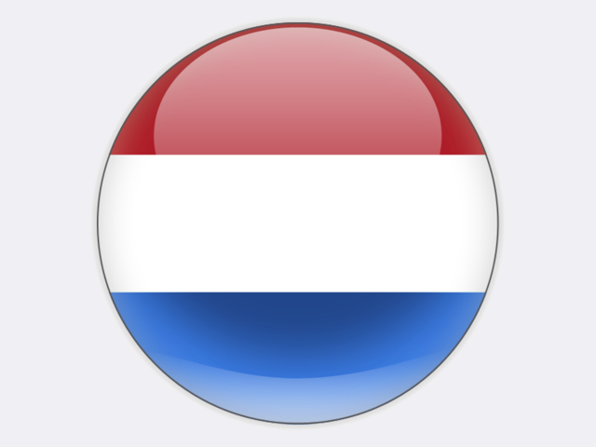

## The Netherlands

Hard coal mining dominated the South Limburg area of the Netherlands from the late 19th century to the mid-1970s. The coalfield, located in the south of the country close to the German and Belgian borders, was mainly exploited from underground mines. Coal mining in the Netherlands ended in 1974 when the private Oranje-Nassau Mine I and Julia coal mines closed. Emma mine, the last state-owned mine, was closed in 1973.

Since around 1915, lignite was extracted at opencast mines near the towns of Eygelshoven and Hoensbroek. The deposits are located on the north-west fringe of the large Rhenish lignite basin to the west of Cologne in Germany. Lignite mining ended in 1968 with the closure of the Carisborg site.

The Netherlands is home to the main ports for the transhipment of coal imports into Europe. The ports at Amsterdam and Rotterdam, along with Antwerp port in Belgium, together make up the ARA trading area for imported steam coal and coking coal in north-west Europe.

In 2018, 11.3% of the Netherlands’ primary energy supply was provided by coal, all imported. The country imported 13.0 million tonnes in 2018, comprising 8.8 million tonnes of steam coal and 4.2 million tonnes of coking coal. The main supplier countries were Russia, the United States, Australia and Colombia.

Most imported coal is used for coal-fired power generation: coal had a 26.3% share of the 113.5 TWh gross electricity generation in 2018, including the use of coke oven gas and blast furnace gas at steelworks. The fleet of Dutch coal power plants is very modern and includes: UNIPER 1 070 MW Maasvlakte 3 plant in the Rotterdam area, ENGIE 800 MW Maasvlakte plant, commissioned in early 2015, and RWE 1 560 MW Eemshaven plant near Groningen. All three of these plants employ the latest supercritical steam technologies to achieve high energy efficiencies. Older coal-fired plants operate at Geertruidenberg (600 MW Amer) and Amsterdam (630 MW Hemweg 8). Some plants co-fire coal with biomass, to a greater or lesser extent. Ownership is very diverse, with ESSENT (a subsidiary of RWE), ELECTRABEL (a subsidiary of ENGIE), UNIPER and NUON (a subsidiary of VATTENFALL) being the major players in coal-fired power generation.

Under the Climate Act of 2018, the Netherlands has committed to reduce its greenhouse gas emissions by 49% by 2030 and by 95% by 2050, compared with 1990 levels. In its Climate Agreement of June 2019, the national coalition government agreed to phase out coal-fired electricity generation by 2025/2030, with the first plant to be closed by 2020 and the three modern plants at the beginning of 2030. The government will introduce a targeted carbon levy on industry, starting at €30 per tonne of CO2 in 2021 and rising to €125-€150 per tonne in 2030, including the EU ETS allowance price, on emissions that exceed a fixed reduction path. A minimum CO2 price for electricity production will also be introduced.

In response to these political developments, ENGIE agreed the sale in April 2019 of its Maasvlakte and other plants to RIVERSTONE HOLDINGS of the United States for an average of €85 per kilowatt (compared with Maasvlakte’s investment cost of €1 500 per kilowatt in 2009). In the case of NUON, the Dutch government has ordered the company to close Hemweg 8 by the end of 2019. Meanwhile, RWE will convert its Eemshaven plant to co-fire biomass.

The Dutch government has supported CCS demonstration projects, including the ROAD project (Rotterdam Opslag en Afvang Demonstratieproject). Under the Climate Agreement, subsidies will be offered to CO2-reducing options in industry, such as CCUS.

TATA STEEL owns the IJmuiden integrated steel works which has a crude steel annual production capacity of 7 million tonnes and consumes most of the coking and PCI coal imported by the Netherlands. A pilot project at IJmuiden to demonstrate the Hisarna iron-making process aims to reduce CO2 emissions from steelmaking.