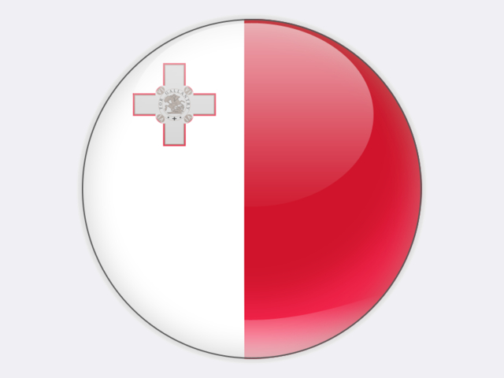

## Malta

Malta has no conventional energy production and reports no coal consumption. Until 1995, coal was imported for power generation. The inefficient 90 MW Marsa and 444 MW Delimara 1 power plants, both running on heavy fuel oil, were decommissioned in 2015 and 2017 respectively. To replace them, ENEMALTA PLC built Delimara 4 – a 205 MW combined cycle gas turbine plant supplied from a floating LNG import facility. In addition, the 153 MW Delimara 3 power plant, commissioned in 2012 and comprising eight diesel engines and a steam turbine, has been converted to run on fossil gas. For security of supply reasons, four engines can also run on diesel oil. A 120-kilometre 200 MW interconnector to Sicily was commissioned in 2015.