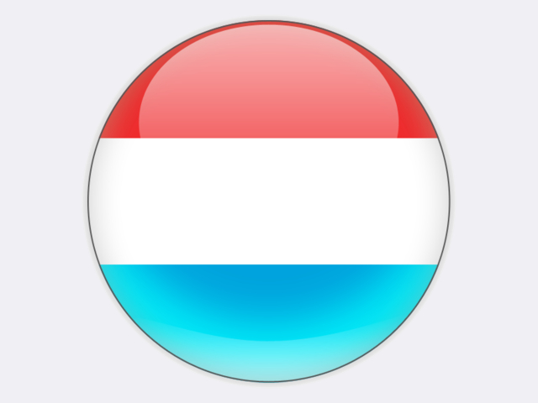

## Luxembourg

In 1952, when its prosperity was based on steelmaking, the Grand Duchy of Luxembourg was chosen as the site of the European Coal and Steel Community, marking the start of the institutional development that led to the European Union. Luxembourg continues to enjoy strong economic growth, of over 2.5% per year, and a growing population.

With an energy-import dependence of 95%, Luxembourg is among the most import-dependent EU member states, after Malta and Cyprus. The country has only one major power generation site: the RWE-operated 1 300 MW pumped-storage hydro plant at Vianden. A 385 MW combined-cycle gas turbine plant at Esch-sur-Alzette operated by TWINERG was prematurely closed in 2016 for economic reasons. Luxembourg thus generates only one quarter of its electricity needs (excluding pumped hydro) and imports the rest, mainly from Germany. It is part of the DE/AT/LU bidding zone and, since October 2017, the BeDeLux interconnector between Belgium, Germany and Luxembourg has been in operation, while a new DeLux interconnector is planned.

The steel industry’s conversion to electric-arc furnaces (ARCELORMITTAL steel works at Esch-Belval and Differdange) has practically eliminated Luxembourg’s coal use and means the sector accounts for around 40% of total electricity demand. Coal is used today mainly for the production of cement at the CIMALUX Rumelange plant. All coal is imported – 63 thousand tonnes in 2018 – and makes only a small contribution to the country’s primary energy supply. Yet, in 2017, Luxembourg had the highest *per capita* greenhouse gas emissions by far (20.2 tCO2e/capita) of all the EU member states.