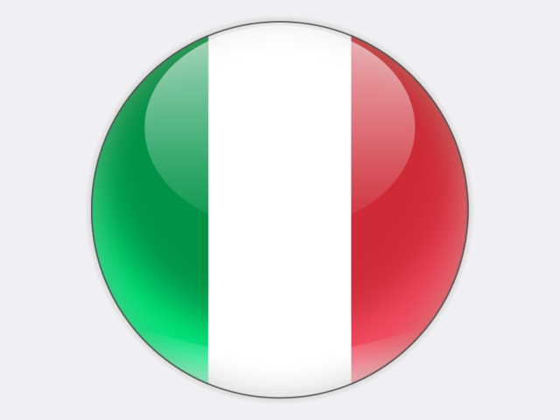

## Italy

Italy has a very low demand for coal. In 2018, coal covered only 5.8% of primary energy supply which totalled 215.6 million tonnes of coal equivalent, this being 19.2% below its 2005 peak. Emissions of CO2 from fossil fuel use fell even more – by 31.1% since 2005 – as the Italian energy mix shifted towards fossil gas and renewable energy sources. Since 1990, Italy’s greenhouse gas (GHG) emissions have fallen by almost 20%.

The only coal reserves and resources in Italy are located in the Sulcis-Iglesiente basin, in south-west Sardinia, totalling an estimated 610 million tonnes. Mining activities were stopped there in 1972, but restarted in 1997 with many environmental improvements. Saleable production in 2018 was an estimated 243 tonnes, although for economic reasons this was left underground. In accordance with EU state-aid law, CARBOSULCIS, owned by the Regional Government of Sardinia, closed Monte Sinni mine at Nuraxi Figus in December 2018. The agreed closure plan foresees work on safety and environmental restoration, renewable energy projects and research activities aimed at the industrial redevelopment of the site though to 2027.

Italian electricity production is uniquely fragile, with no solid baseload nuclear or coal power. On average, G7 countries rely on coal and nuclear for 43.8% of their power generation. In Italy, the comparable figure is just 10.5%, all from coal. This means an overdependence on fossil gas which accounted for 44.6% of gross power generation in 2018, followed by hydro (17.0%), solar (7.8%), wind (6.0%) and oil (3.7%). Biofuels, energy from waste and geothermal accounted for the balancing 10% of electricity production. After growing strongly under five *Conto Energia* schemes which ended in 2013 and other green subsidies, the share of new renewables (solar, wind and biofuels) stagnated over the five-year period to 2018 at around 20%. Net electricity imports of 43.9 TWh in 2018 met over 13% of gross electricity supply.

In a decisive June 2011 referendum, Italian voters rejected government proposals to restart a nuclear programme that was abandoned following an earlier referendum held after the 1986 Chernobyl disaster.

Italy had an overall energy import dependence of 77.0% in 2017, rising to 92.3% in the case of fossil gas. In 2018, fossil gas imports came mainly from Russia (48%), Algeria (27%) and Qatar (10%). Italy also imported 10.8 million tonnes of steam coal in 2018 and 3.3 million tonnes of coking coal, the latter including PCI coal. The main supply countries were Russia, the United States and Colombia. In October 2017, ENEL sold its 10% shareholding in PT BAYAN RESOURCES of Indonesia which produced 20.9 million tonnes of coal in 2017 and 28.9 million tonnes in 2018. Coal imports into Italy peaked in 2008 at 25.1 million tonnes and have since fallen because of the forced closure of the 660 MW Vado Ligure coal-fired power plant owned by TIRRENO POWER, the closure of a further three coal power plants (Brindisi Nord, Genoa and “Pietro Vannucci” Bastardo in Umbria) and ongoing difficulties at the ARCELORMITTAL steel plant in Taranto.

Mainland Italy now has just six coal-fired power plants: ENEL Torrevaldaliga Nord on the coast near Rome (1 320 MW), ENEL Andrea Palladio-Fusina near Venice (960 MW), ENEL Brindisi Sud “Federico II” (2 640 MW), A2A Monfalcone (336 MW), ENEL “Eugenio Montale” at La Spezia (600 MW) and A2A Brescia (70 MW).

Following their modernisation and conversion from fuel oil to coal, Italy has some of the best-performing coal-fired power plants in Europe. The Torrevaldaliga Nord power plant attains a net efficiency of 45%, thus matching the world-leading performance of plants in Japan. It is estimated that, by 2038, all the modernisation investments at Italian coal power plants will have been fully amortised. However, Italy’s coal-fired power plants are destined to reduce their output and close before then.

On 8 January 2019, the Italian government presented to the European Commission its draft Integrated National Energy and Climate Plan (PNIEC). In it, great emphasis is placed on an acceleration of decarbonisation policies and the promotion of renewable energy sources as part of an economy-wide transformation. For coal, the plan confirms what was proposed in the National Energy Strategy of 2013, *i.e.* the closure of all Italian coal-fired power plants by 2025.

To protect the competitiveness and security of the Italian power system, the planned coal phase-out is to be gradual and closely connected to power plant replacement and extension of power transmission, distribution and energy storage infrastructure. However, without nuclear and coal, and with the emphasis on more expensive renewables, Italy faces an uncompetitive power generation mix that will contribute to weaker industrial activity and higher electricity prices for households. The closure of coal plants will exclusively benefit oligopolistic gas producers, such as GAZPROM, the largest Russian company, and SONATRACH, the Algerian state-owned oil company.

Absent appropriate actions, there are serious issues with the coal phase-out plan. For example, the closure of the two coal-fired power plants on Sardinia (640 MW EPH Fiumesanto and 340 MW ENEL Sulcis “Grazia Deledda”) appears to be technically impossible as they account for 70% of the island’s power production. The same situation affects Italy’s central-northern grid which already experiences security and adequacy problems.

Moreover, from an environmental point of view, in a world where coal will continue to be used for power generation, the coal phase-out plan will be of little climatic benefit as the CO2 emissions from coal-fired power generation in Italy accounted for just 0.06% of global GHG emissions in 2018.