# Hungary

Since 2013, Hungary’s export-oriented economy has grown strongly; GDP grew by a healthy 5.1% in 2018. The country enjoys almost full employment with an unemployment rate of just 3.6% at the end of 2018, thanks partly to a public work scheme. Due to its sparse energy and raw material resources, Hungary is import dependent.

Total conventional energy resources in Hungary comprise about 10.5 billion tonnes of coal, 4.1 trillion cubic metres of fossil gas (including unconventional) and 0.8 billion cubic metres of oil (including unconventional). Lignite and brown coal reserves account for about half of Hungary’s total coal resources and are the most important indigenous sources of energy currently exploited.

Hungary’s primary energy consumption in 2018 amounted to 38.1 Mtce. Fossil gas had the biggest share in this total (31.3%), followed by oil (29.2%), nuclear energy (15.4%), combustible renewables and waste (10.3%) and coal (8.1%). Hungary aims to increase the share of renewable energy in gross final energy consumption to 14.65% by 2020 and 20% by 2030.

Hungary is a net importer of energy and in 2017 had an overall energy import dependency of 62.6%. In 2018, import dependencies were as follows: oil 89%, fossil gas 78% and coal 49%.

National electricity generation in 2018 totalled 31.9 TWh from an installed capacity totalling around 9.2 GW. A net 14.3 TWh of electricity was imported. Nuclear energy from Hungary’s sole nuclear power plant at Paks accounted for 49.4% of gross electricity production. This state-owned plant has four reactors with a combined gross capacity of 2 000 MW. As a result of a service lifetime extension programme, the four units at Paks will operate for another fifteen to twenty years. Paks II (2 × 1 200 MW) has been approved for constructed on the same site; the new units 5 and 6 are expected to start operation in the late 2020s. Gas-fired generation also makes a major contribution to national electricity supply; it had a share of 22.7% in 2018. Electricity produced from coal, including lignite, had a share of 15.1% in gross electricity production in 2018, generated mainly by MÁTRAI ERÖMÜ ZRT which is majority owned by OPUS GLOBAL. Renewable energy sources had a share of 11.6%, mostly biomass, followed by equal shares from wind turbines and solar PV, then biogas, municipal and industrial wastes, hydro and some geothermal. A new support scheme for renewable power generation was adopted in June 2016, with feed-in tariffs and premiums that have led to a surge in solar PV projects.



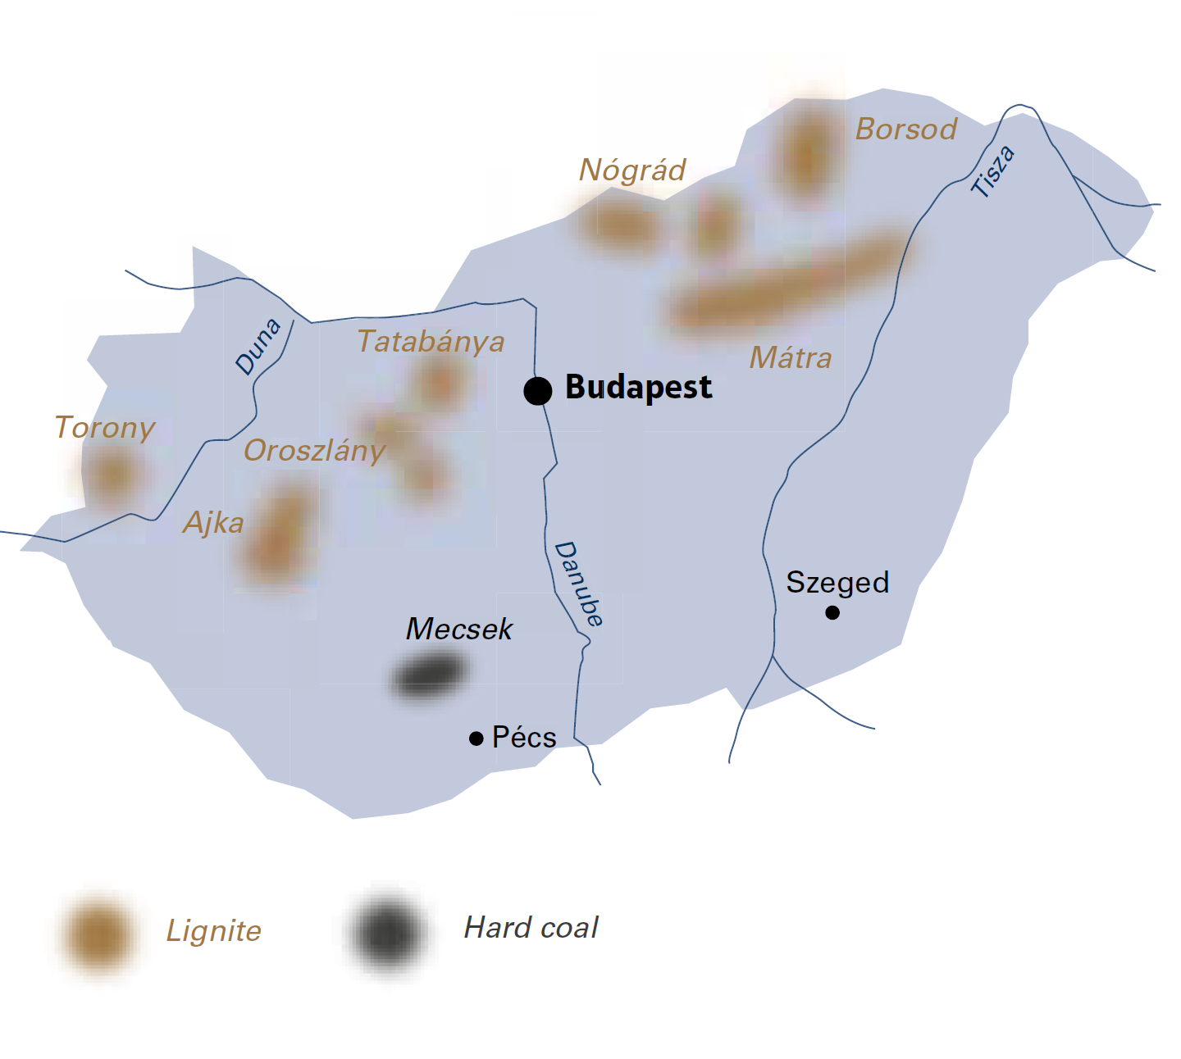

|  |  |  |
| --- | --- | --- |
| General data |  | 2018 |
| Population | million | 9.8 |
| GDP | € billion | 131.9 |
| Per capita GDP | €/person | 13 500 |

The second *National Climate Change Strategy*, approved by the Hungarian parliament in October 2018, targets a 40% reduction in greenhouse gas (GHG) emissions by 2030, compared with 1990, and a 52% to 85% reduction of gross GHG emissions by 2050. The Ministry of Innovation and Technology (MIT) is developing a new *National Energy Strategy* in which a climate-friendly electricity mix will be central to achieving these targets.

## Lignite

Hungary’s lignite and brown coal resources are concentrated in the regions of Transdanubia and in northern and north-eastern Hungary. In 2018, Hungary’s total lignite output was 7.9 million tonnes. Almost all of this was used for heat and power generation, with only small quantities supplied elsewhere, mainly to households.

Since the closure in 2014 of the Márkushegy underground mine in western Hungary, all lignite production has been at opencast mines, principally the Visonta and Bükkábrány mines belonging to MÁTRAI ERŐMŰ ZRT (MÁTRA). The approved mining fields of these two opencast mines have about 770 million tonnes of lignite reserves.

In 2018, MÁTRA produced 7.8 million tonnes of lignite and removed 52.1 million cubic metres of overburden. The lignite is used in the company-owned power plant at Visonta which comprises four lignite-fired units and two topping gas turbines. Lignite from the Bükkábrány mine, some 50 kilometres from the power plant, is transported by rail while a conveyor belt links the plant to the adjacent Visonta mine. Besides lignite and fossil gas, biomass is co‑fired to a fuel input level of around 10%.

The MÁTRA power plant at Visonta, located 90 kilometres north-east of Budapest, has a total capacity of 966 MW (2 x 100 MW units, 1 x 220 MW unit, 2 x 232 MW units, 2 x 33 MW gas turbines and, since 2015, a 16 MW solar park which was sold in 2018). The wet flue gas desulphurisation (FGD) system commissioned in 2000 at Visonta is interesting as it is installed inside dry cooling towers and makes use of the natural draft to release flue gas high into the atmosphere. The plant is also fitted with selective, non‑catalytic NOx reduction (SNCR) to further reduce pollutant emissions. Additional wet cooling cells have been added to units 4 and 5 to create a hybrid cooling system that improves efficiency.

As part of its development strategy, MÁTRA has created an industrial park at Visonta with many activities related to the power plant, such as block manufacture using bottom ash and fly ash, plasterboard production using gypsum from the FGD system and biomass fuel processing. A new 60 MW solar PV farm is proposed for the overburden deposit at the Bükkábrány mine. Looking to the future, MÁTRA has plans for a 450 MW gas-fired CCGT, a 100 MW biomass plant, a 31.5 MW refuse-derived fuel plant and 50 MW of battery storage, as well as bigger solar farms totalling 200 MW and a solar panel factory at Visonta and Halmajugra. In the Mátra mountains, a site has been identified for a 600 MW pumped storage scheme which can proceed if there is a market demand and political support. Plans also exist for a new 500 MW lignite-fired unit with 42% efficiency. The future trajectory of the Visonta site will depend on decisions taken by the Hungarian government and local authorities, as well as the many other stakeholders involved, all within the framework of the EU’s evolving climate and energy policy.

## Hard coal

At the end of 2014, trial coal mining operations began in the Mecsek region. In 2018, PANNON HŐERŐMŰ ZRT extracted some quantities of coal from its Pécs-Vasas opencast mine in the region. This coal is officially classified as lignite due to its low calorific value.

Hungary

|  |  |  |
| --- | --- | --- |
| Coal resources and reserves |  | as at 1.1.2018 |
| Total resources hard coal | Mt | 4 821 |
| Total resources lignite | Mt | 5 687 |
| Reserves hard coal | Mt | 4 157 |
| Reserves lignite | Mt | 4 241 |

|  |  |  |
| --- | --- | --- |
| Primary energy production |  | 2018 |
| Total primary energy production | Mtce | 15.8 |
| Hard coal (saleable output) | Mt / Mtce | 0.002 / 0.0 |
| Lignite (saleable output) | Mt / Mtce | 7.9 / 1.8 |

|  |  |  |
| --- | --- | --- |
| Saleable coal quality |  |  |
| Hard coal net calorific value | kJ/kg | 17 549 |
| Lignite net calorific value | kJ/kg | 6 742 |
| Lignite ash content | % a.r. | 23.0 |
| Lignite moisture content | % a.r. | 47.4 |
| Lignite sulphur content | % a.r. | 1.2 |

|  |  |  |
| --- | --- | --- |
| Coal imports / exports |  | 2018 |
| Hard coal imports | Mt | 1.5 |

|  |  |  |
| --- | --- | --- |
| Primary energy consumption |  | 2018 |
| Total primary energy consumption | Mtce | 38.1 |
| Hard coal consumption | Mtce | 1.5 |
| Lignite consumption | Mtce | 1.8 |

|  |  |  |
| --- | --- | --- |
| Power supply |  | 2018 |
| Total gross power generation | TWh | 31.9 |
| Net power imports (exports) | TWh | 14.3 |
| Total power consumption | TWh | 43.3 |
| Power generation from lignite | TWh | 4.5 |
| Lignite power generation capacity | MW | 783 |

|  |  |  |
| --- | --- | --- |
| Employment |  | 2018 |
| Direct in lignite-mining | thousand | 1.400 |
| Other lignite-related* | thousand | 0.800 |

* i.e. in power generation at MÁTRA power plant