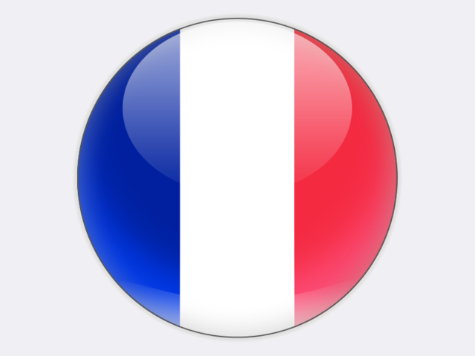

## France

Coal resources in France are estimated by the French geological survey (BRGM) to be 425 million tonnes of hard coal and 300 million tonnes of lignite. Hard coal mining in France ended in April 2004 with the closure of the last operational mine, La Houve in the Lorraine region. The state-owned coal company Charbonnages de France ceased activity at the end of 2007. Today, all coal is imported.

In 2018, coal imports amounted to 13.5 million tonnes, including 4.6 million tonnes of coking coal from Australia and the United States. Coal is delivered through the ports of Dunkerque, Le Havre, Rouen, Montoir and Fos-sur-Mer, as well as via the ARA ports. Coal consumption amounted to 13.2 million tonnes in 2018, of which an estimated 3.9 million tonnes were consumed for power generation.

Gross power generation in France was 580.7 TWh in 2018, with 71.1% of this total generated at nuclear power plants. Conventional thermal power generation contributed 9.9%, hydro 11.2%, wind 4.9% and solar PV 1.8%. Coal-fired power generation accounted for 1.6% of the total while the overall share of renewables was 18.9%.

In compliance with the Large Combustion Plants Directive, the number of operational coal-fired power generation units in mainland France was reduced to five in 2015. According to the *Programmation pluriannuelle de l’énergie* published in November 2018, the French government wants to end coal-fired power generation by the end of 2021.

Today, the largest coal power plants are located adjacent to ports at Cordemais (2 × 600 MW) and Le Havre (600 MW). Both are owned by EDF which plans to close the Le Havre plant in spring 2021 and convert the Cordemais plant to biomass by spring 2022. In July 2019, UNIPER announced the sale to EPH of all its assets in France, including the 600 MW Émile-Huchet unit 6 at Saint-Avold in Lorraine and the 600 MW Gardanne unit 5 in Provence, as well as a 150 MW unit converted to biomass known as “Provence 4 Biomasse” which was initially commissioned in 2017, but has run only intermittently since then. There are also three 100 MW coal-fired power plants in French overseas territories: one in Guadeloupe and two in Réunion. During sugar campaigns, these plants also use renewable bagasse.

The French steel industry consumes important volumes of coal – around 4.5 million tonnes for coke making and 3.0 million tonnes at integrated steel works in 2018. ARCELORMITTAL plants at Dunkerque and Fos-sur-Mer are the biggest coal consumers in this sector.