# Spain

Following the global economic crisis, Spain’s economy has been growing since 2014; annual growth was 2.6% in 2018. The unemployment rate remains very high at around 15%.

The country is highly dependent on imported oil and fossil gas. It had an overall import dependence of 73.9% in 2017, well above the EU average of 55.1%. This places a burden on the Spanish economy by increasing its trade deficit and foreign indebtedness. Spain’s primary energy production was 48.6 Mtce in 2018, notably nuclear – just 2.3% came from indigenous coal production.

The only significant conventional energy resource that Spain possesses is coal, totalling 4 550 million tonnes, including accessible reserves of 1 187 million tonnes. In 2018, coal met 7.8% of the country’s energy demand: 2.5 million tonnes of domestic production and 15.8 million tonnes of imported coal. Oil, fossil gas and nuclear are the other principal energy sources, with wind and solar providing 5.9% of total primary energy supply. However, after a decade of growth, wind and solar power have been in *decline* since their 2013 peak.

Electricity produced in 2018 came mainly from conventional sources: nuclear power with 55.6 TWh gross (20.3%), followed by fossil gas 57.1 TWh (20.8%), wind 50.8 TWh (18.6%), hard coal 39.3 TWh (14.4%) and hydro which had a good year with 36.8 TWh (13.4%). Solar, wind and other renewable energy sources accounted for 38.6% of electricity generation in 2018. Indigenous coal fuelled around 2% of generation.

Spain has one of the most dynamic electricity markets in Europe. There is fierce competition between coal-fired and fossil gas-fired power generation for the market that remains after nuclear, hydro and must-run renewables have supplied. Hydro output can vary significantly from one year to the next and, with a system capacity margin of over 150%, there is plenty of room for switching between sources.

Spain plans to be a carbon-neutral country by 2050. In its draft *National Energy and Climate Plan 2021-2030*, submitted to the European Commission in February 2019, the government expects coal power plants to cease operation by 2030 at the latest, driven out of the market by the high cost of CO2 allowances under the EU emissions trading system. Of the fifteen coal-fired power plants operational in 2019, only six are expected to continue after 2021 and coal consumption could halve by 2025. By 2030, the government wants to more than double wind power capacity and increase solar PV capacity eight fold.

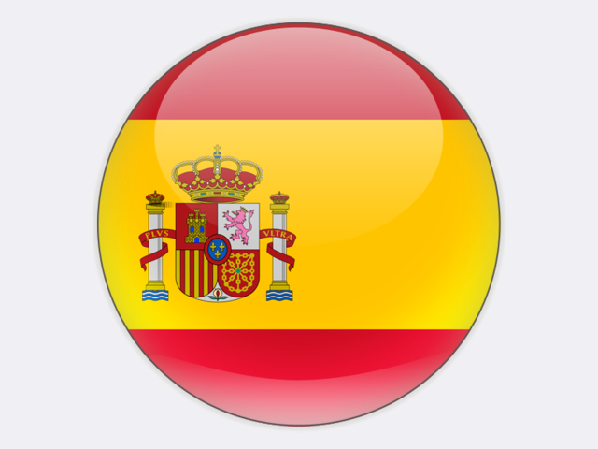

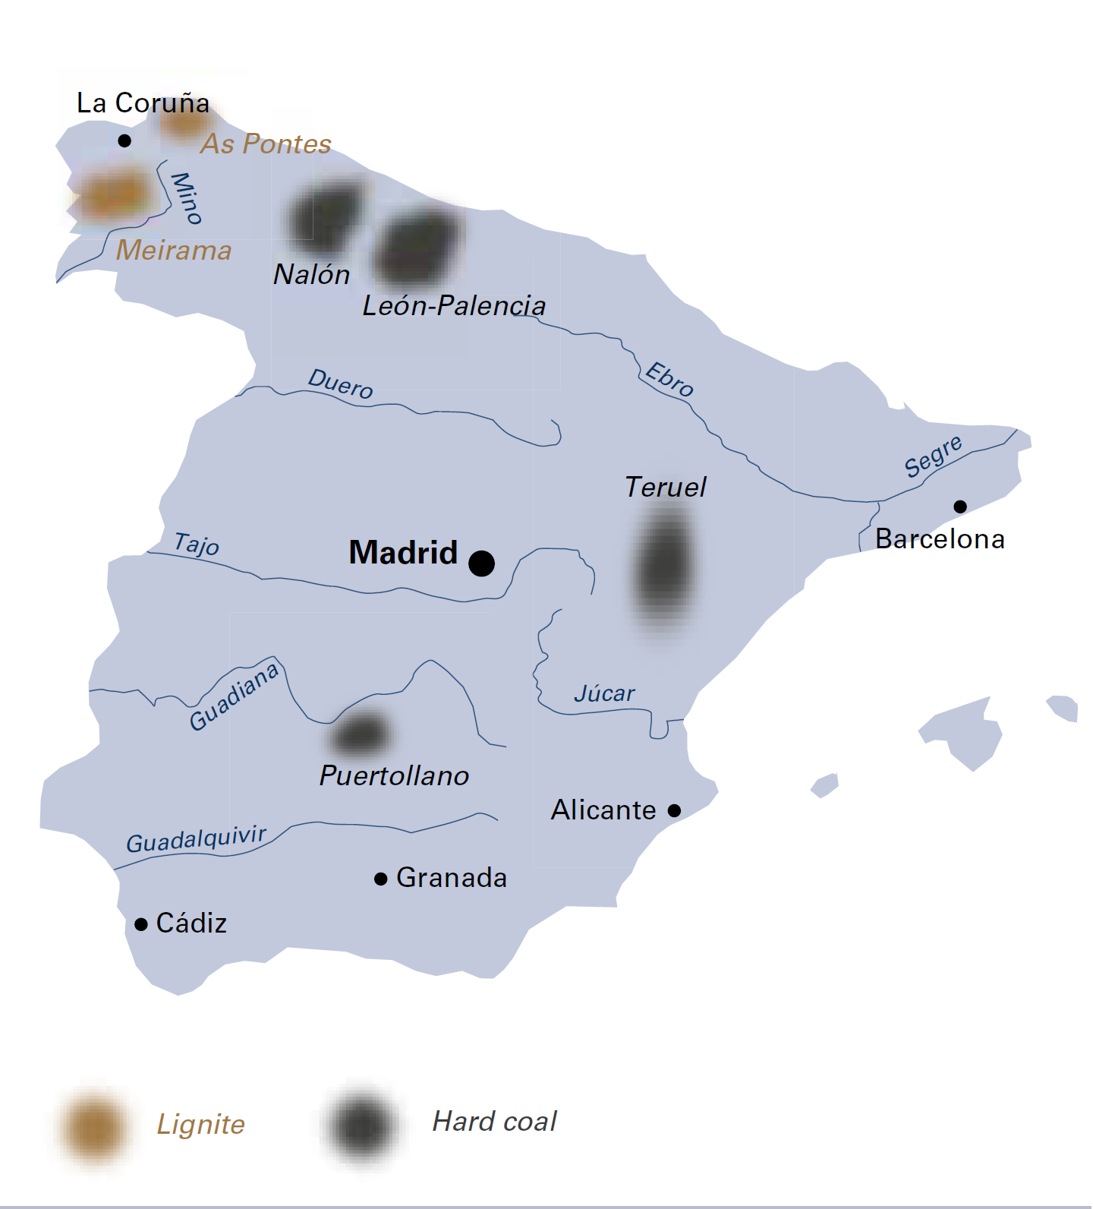

|  |  |  |
| --- | --- | --- |
| General data |  | 2018 |
| Population | million | 46.9 |
| GDP | € billion | 1 202.2 |
| Per capita GDP | €/person | 25 700 |

## Hard coal

Hard coal deposits in the north-west Principality of Asturias are located in the Nalón Valley and are of a low calorific value. Nevertheless, in the past they were Spain’s biggest source of coal. Today, high extraction costs have led to the gradual closure of mines and only one remains: the San Nicolás underground coal mine located in the Lleros de Abajo valley near Mieres which produces up to 200 thousand tonnes each year for heating plants and the nearby 15 MWe La Pereda experimental power plant. Over 1 000 people are employed by HUNOSA at these operations. The deposits at León-Palencia are also of a low calorific value, although some anthracite seams are present. Coal in the Astur-Leonesa basin north of La Robla in the region of Castilla y León, where anthracite was mined by HULLERA VASCO-LEONESA and CARBONAR, has a high calorific value (5 500 kcal/kg or 23 000 kJ/kg) and low volatile matter.

The hard coal basin at Puertollano in the Ciudad Real province south of Madrid has good reserves. The province of Teruel in the Aragon region boasts the largest sub-bituminous hard coal reserves in Spain. The high sulphur content of this coal (4% to 6%) made it less attractive for use at power plants in the past.

In May 2016, the European Commission announced that the Spanish government’s plan of October 2013 to grant €2.13 billion for the orderly closure of twenty-six coal mines by 2018 was in line with EU rules on state aid, in particular Council Decision 2010/787/EU (case SA.34332).

By the end of 2018, all Spanish coal producers had closed their mining operations: BIERZO ALTO, CARBONES ARLANZA, CARBONAR, CARBONES DEL PUERTO, CÍA GRAL MINERA DE TERUEL, CÍA ASTUR LEONESA, ENDESA, ENCASUR, HIJOS DE BALDOMERO GARCÍA, HULLERA VASCO-LEONESA, MINERA CATALANO ARAGONESA, UNIÓN MINERA DEL NORTE and HULLERA DEL NORTE. Subsidies paid in 2018, effectively the last year of production, totalled €210 000 or just €0.085 per tonne. Following several bankruptcies, only four companies will continue in 2019, carrying out restoration work at former mines.

Even those coal mining companies that remained viable without subsidy were forced to close by 31 December 2018, because under EU law continued mining would have required the repayment of *past* state aid received since 2011 – an impossible demand that led to thousands of job losses. Negotiations with the Spanish government for a just and orderly transition of the coal sector were disrupted by a change of government in June 2018 and, by mid-September, it was clear that mine closures were inevitable.

On 24 October 2018, a framework agreement was signed for the “Just Transition from Coal Mining and Sustainable Development of Mining Regions 2019-2027”. Following proposals by trade unions (FICA-UGT, CCOO and USO), this agreement is favourable for mineworkers, although subcontractors were excluded. In contrast, representations by coal mining companies, who wanted flexibility on the repayment of past state aid, led nowhere. To secure workers’ rights, the agreement was signed by CARBUNIÓN on behalf of the mining companies. It foresees:

* restructuring of the coal sector within the framework of Council Decision 2010/787/EU;
* economic development of the coal mining regions;
* flexibility for companies who wish to continue mining coal beyond 2018; and
* mitigating the impacts of job losses and mine closures.

The government will therefore grant support for redundancy payments and early retirements, exceptional mine closure costs, mitigation of environmental impacts, land restoration, and state aid totalling €250 million over the 2019-2023 period for new or expanding businesses, as well as local infrastructure.

Spain

|  |  |  |
| --- | --- | --- |
| Coal resources and reserves |  | as at 1.1.2018 |
| Total resources hard coal | Mt | 4 231 |
| Total resources lignite | Mt | 319 |
| Reserves hard coal | Mt | 868 |
| Reserves lignite | Mt | 319 |

|  |  |  |
| --- | --- | --- |
| Primary energy production |  | 2018 |
| Total primary energy production | Mtce | 48.6 |
| Hard coal (saleable output) | Mt / Mtce | 2.5 / 1.4 |

|  |  |  |
| --- | --- | --- |
| Saleable coal quality |  |  |
| Hard coal net calorific value | kJ/kg | 18 231 |
| Hard coal ash content | % a.r. | 34.6 |
| Hard coal moisture content | % a.r. | 13.2 |
| Hard coal sulphur content | % a.r. | 2.5 |

|  |  |  |
| --- | --- | --- |
| Coal imports / exports |  | 2018 |
| Hard coal imports | Mt | 15.8 |

|  |  |  |
| --- | --- | --- |
| Primary energy consumption |  | 2018 |
| Total primary energy consumption | Mtce | 177.4 |
| Hard coal consumption | Mtce | 13.9 |

|  |  |  |
| --- | --- | --- |
| Power supply |  | 2018 |
| Total gross power generation | TWh | 273.8 |
| Net power imports (exports) | TWh | (11.1) |
| Total power consumption | TWh | 284.9 |
| Power generation from hard coal | TWh | 39.3 |
| Hard coal power generation capacity | MW | 9 562 |

|  |  |  |
| --- | --- | --- |
| Employment |  | 2018 |
| Direct in hard coal mining | thousand | 1.549 |

The FUNDACIÓN CIUDAD DE LA ENERGÍA (CIUDEN) is the leading public developer of CO2 capture, transport and geological storage in Spain. CIUDEN also has a prominent role in the just transition of coal mining regions, acting as co‑ordinator for economic development initiatives and viable projects to create employment, in addition to bringing its own technical capacity.

## Lignite

At the end of 2007, Spain’s last lignite mines located in Galicia on the north-west side of the Iberian Peninsula were closed. Lignite reserves of 319 million tonnes remain.