# Greece

Accounting in 2018 for 20.5% of the country’s primary energy supply of 32.3 Mtce, lignite is Greece’s most important indigenous energy resource, although the country does have modest oil and gas reserves. At 0.3 Mtce, hard coal imports accounted for 0.9% of energy supply. Oil accounted for 45.9% of total primary energy supply in 2018; Greece has a large refining industry which exports oil products. Fossil gas had an 18.2% share in primary energy supply in 2018. Electricity trade has grown steadily over the years, although the global economic crisis disrupted first imports and then exports. In 2018, electricity imports into Greece reached 8.7 TWh.

Security of supply, low extraction costs and stable prices are important reasons why lignite still maintains a significant share in the Greek energy mix. However, in September 2019, Prime Minister Kyriakos Mitsotakis pledged to phase out lignite-fired power generation by 2028.

## Lignite

Greece boasts lignite resources of 3.6 billion tonnes and 2.9 billion tonnes of economically workable reserves. The most important deposits are located in the north of the country at Ptolemais-Amynteon and Florina (1.6 billion tonnes) which contribute around 80% of production. Other deposits lie at Drama (900 million tonnes) and at Elassona (170 million tonnes), as well as in the south at Megalopolis (132 million tonnes). There is also a large peat deposit of about 4 billion cubic metres at Philippi in the northern part of Greece (Eastern Macedonia). Only 30% of the total lignite reserves have been extracted to date and remaining reserves are good for over forty years at current production rates.

Lignite deposits in Greece lie at an average depth of 150 to 200 metres and typically comprise layers of lignite alternating with mineral layers.

The quality of Greek lignite can be characterised as follows: the lowest calorific values are in the areas of Megalopolis and Drama (3 770 to 5 020 kJ/kg) and Ptolemais-Amynteon (5 230 to 6 280 kJ/kg). In Florina and Elassona the calorific value lies between 7 540 and 9 630 kJ/kg. The ash content ranges from 15.1% (Ptolemais) to 19.0% (Elassona), and the water content from 41.0% (Elassona) to 57.9% (Megalopolis). At less than 1%, the sulphur content is generally low.

Lignite is mined by the PUBLIC POWER CORPORATION (PPC) exclusively in opencast mines. This majority state-

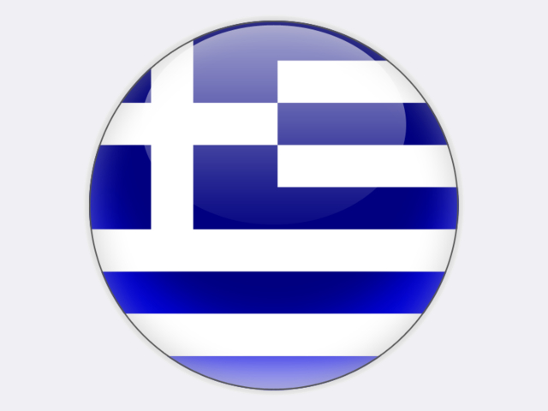

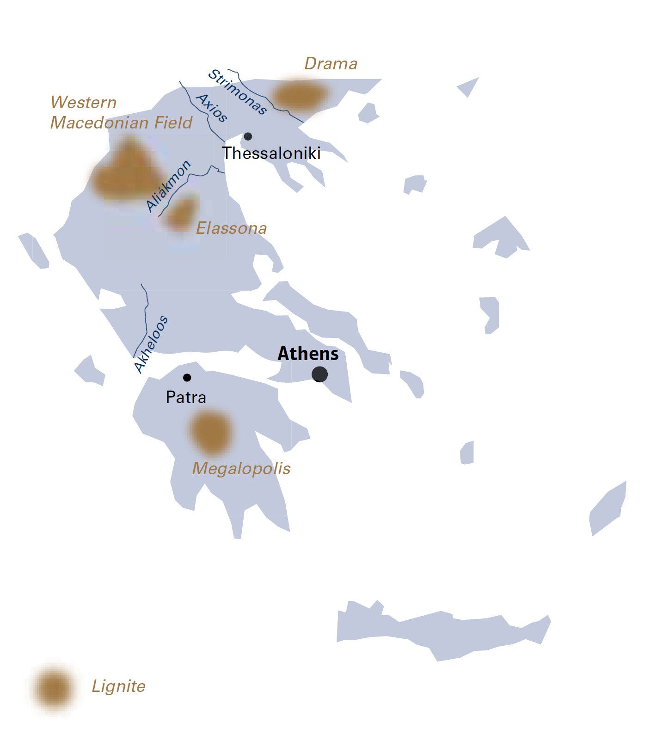

|  |  |  |
| --- | --- | --- |
| General data |  | 2018 |
| Population | million | 10.7 |
| GDP | € billion | 184.7 |
| Per capita GDP | €/person | 17 200 |

owned company is the largest lignite producer in Greece and operates mines in Western Macedonia at Main Field, South Field, Kardia Field and Amynteon Field. LIGNITIKI MEGALOPOLIS SA, a 100% owned subsidiary of PPC, also operates an opencast site in the Peloponnese region of southern Greece, in the Megalopolis Field.

Bucket-wheel excavators, spreaders, tripper cars and conveyor belts are used to mine and transport lignite at these sites. PPC currently operates forty-three bucket-wheel excavators and twenty-two spreaders, together with more than 300 kilometres of belt conveyors. Hydraulic excavators and heavy trucks are used to remove the hard overburden formations found at some mines.

In 2018, lignite production amounted to 36.5 million tonnes, mostly mined by PPC, with 27.2 million tonnes extracted by the company at the West Macedonia Lignite Centre (WMLC) and 7.4 million tonnes at the Megalopolis Lignite Centre (MLC). The few privately operated mines in the West Macedonia area produced a total of 1.9 million tonnes of lignite.

In 2018, WMLC operations removed a total of 143.7 million cubic metres of overburden and interburden, corresponding to an overburden-interburden-to-lignite ratio of 5.3 cubic metres per tonne. At MLC, overburden plus interburden removal was 15.8 million cubic metres, corresponding to an overburden-interburden-to-lignite ratio of 2.1:1. Although the overburden-interburden-to-lignite ratio has significantly increased in recent years, it is expected to remain stable in the future. The two mining areas, WMLC and MLC, and the head office in Athens, employed during 2018 a total permanent workforce of about 4 082.

Environmental protection is one of the major parameters defining PPC’s overall strategy and its daily mining activities. In the lignite mining areas around Ptolemais-Amynteon and Megalopolis, PPC has carried out site restoration projects to create farmland, tree plantations, woodland, animal sanctuaries and crop-testing areas.

At the end of 2018, power generation plants owned by PPC and its subsidiaries accounted for 60.6% of the country’s total installed capacity of 21.5 GW and include lignite- and gas-fired plants, oil-fired plants on interconnected and autonomous islands, hydro plants, wind farms and solar PV plants. There are also seven private power plants with a total capacity of 2 626 MW. PPC and its subsidiaries own six lignite-fired power plants comprising fourteen units with a total installed capacity of 4 337 MW. In 2018, lignite-fired power plants accounted for 29.2% of net power generation of 51.0 TWh. The share of gas was 27.7%, oil 9.0%, hydro 11.3%, wind 12.3%, solar 7.7%, CHP 2.2% and biofuels/waste 0.6%. The output from solar PV has been flat since 2013 when subsidies were reduced. In 2018, residential consumers paid €23/MWh in renewable subsidies to support wind and solar.

Lignite’s future role in Greece will depend on changes taking place across the European energy sector, including the cost of carbon allowances under the EU emissions trading system. The significant increase in allowance prices during 2018 resulted in a reduction of the competiveness of lignite-fired power generation. PPC faces other important challenges relating to the regulatory framework governing energy market liberalisation, including the forced divestment of lignite-fired units at its Meliti and Megalopolis power stations. Strategic priorities now include the replacement of old and inefficient plants and investment in renewable energy sources. The new 660 MW Ptolemaida V lignite-fired power plant is one priority, with construction by TERNA SA and HITACHI POWER EUROPE of this €1.4 billion project well underway.

In response to declining lignite production, the national government and the regional government of Western Macedonia are working with the World Bank, the European Commission, PPC and other stakeholders on regional development strategies to ensure a smooth transition to alternative means of wealth creation and energy supply.

Greece

|  |  |  |
| --- | --- | --- |
| Coal resources and reserves |  | as at 1.1.2018 |
| Total resources lignite | Mt | 6 430 |
| Reserves lignite | Mt | 2 876 |

|  |  |  |
| --- | --- | --- |
| Primary energy production |  | 2018 |
| Total primary energy production | Mtce | 10.6 |
| Lignite (saleable output) | Mt / Mtce | 36.5 / 6.3 |

|  |  |  |
| --- | --- | --- |
| Saleable coal quality |  |  |
| Lignite net calorific value | kJ/kg | 3 770‑9 630 |
| Lignite ash content | % a.r. | 15.1‑19.0 |
| Lignite moisture content | % a.r. | 41.0‑57.9 |
| Lignite sulphur content | % a.r. | 0.4‑1.0 |

|  |  |  |
| --- | --- | --- |
| Coal imports / exports |  | 2018 |
| Hard coal imports | Mt | 0.4 |

|  |  |  |
| --- | --- | --- |
| Primary energy consumption |  | 2018 |
| Total primary energy consumption | Mtce | 32.3 |
| Hard coal consumption | Mtce | 0.3 |
| Lignite consumption | Mtce | 6.3 |

|  |  |  |
| --- | --- | --- |
| Power supply* |  | 2018 |
| Total net power generation | TWh | 51.0 |
| Net power imports (exports) | TWh | 6.3 |
| Total power consumption | TWh | 57.3 |
| Net power generation from lignite | TWh | 14.9 |
| Lignite power generation capacity | MW | 4 337 |

|  |  |  |
| --- | --- | --- |
| Employment |  | 2018 |
| Direct in lignite mining | thousand | 4.082 |
| Other lignite-related** | thousand | 2.012 |

* including small islands with independent diesel generators

** at PPC lignite-fired power plants