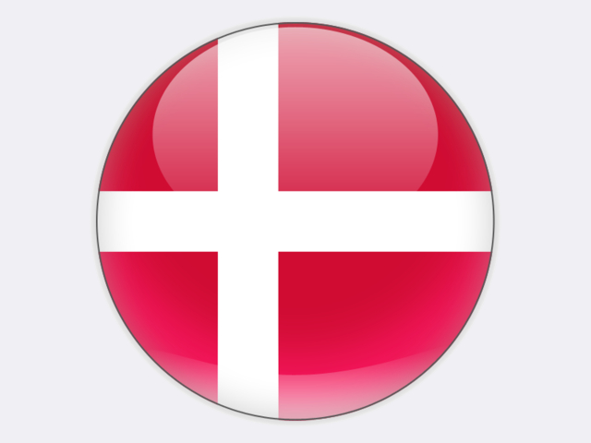

## Denmark

With the rise in its oil and gas production from the North Sea, Denmark became energy self-sufficient in 1999 and, in 2004, a net exporter of primary energy. The country is the third largest oil producer in Western Europe, after Norway and the UK. Gas production in 2018 was 4.1 billion cubic metres, less than half its 2005 peak. Oil and gas production are in decline and Denmark returned to being a net energy importer in 2013. In 2017, Denmark had the second lowest energy import dependence (11.7%) of any EU member state.

Danish energy supply has changed significantly as a result of efforts to promote renewable energy, combined heat and power (CHP) and energy efficiency. All political parties reached an energy agreement in June 2018. This is expected to result in a greater than 100% share of renewables in electricity supply by 2030, while ensuring that at least 90% of district heating is based on energy sources other than coal, oil or gas by 2030. The government’s long-term goal is for a climate-neutral Denmark by 2050.

In 2018, around 70% of gross electricity generation was from renewable sources, predominantly from wind and biomass. The relatively high use of wind turbines for electricity generation (46.3% in 2018) enhances security, but poses balancing challenges. The Danish electricity system has connections to Norway, Sweden and Germany: Denmark’s net electricity imports in 2018 were 5.2 TWh or 15.4% of supply. As part of the integrated Nordic electricity market, Denmark’s thermal power plants play an important role in balancing not only wind power, but also hydro power from Norway and Sweden which depends on annual precipitation.

Coal-fired power plants in Denmark have a total generation capacity of 3.7 GW; many are multi-fuelled with biomass. The majority state-owned ØRSTED runs Asnæs (827 MW), Avedøre (262 MW), Esbjerg (417 MW) and Studstrup (700 MW) power plants. Most units at these plants can burn biomass – wood pellets or straw – the result of ØRSTED’s bio-conversion programme for all its coal- and gas-fired CHP units which will see coal use end by 2023. The 319 MW Amager power plant is owned by HOFOR, the city of Copenhagen’s municipal heat and power company. HOFOR plans to replace its coal use in 2020 when a new biomass unit is commissioned – BIO4 has been under construction since September 2016. Fyn power plant (409 MW) includes a straw-fired boiler and a coal-fired unit, with the latter set to close by 2025. Finally, since 2015, the 410 MW Nordjylland plant has been owned by the local municipality’s utility company, AALBORG FORSYNING.

Nordjyllandsværket 3 is one of the world’s most efficient coal-fired power plants. Its supercritical boilers and steam turbines result in a very high electrical generation efficiency of 47% and, with heat supply, the overall efficiency can exceed 95%.

Denmark has no indigenous coal resources. In 2018, the country imported 2.8 million tonnes of coal, mostly from Russia, South Africa and Colombia. Around 95% of this coal was used for electricity and heat generation. Having peaked in 1984 at 96%, the share of coal in power generation has fallen to 21.4% in 2018 (6.4 TWh) and will be gradually phased out by 2030 under the June 2018 agreement.