# Germany

Germany has the fourth largest economy in the world, after the United States, China and Japan. Following a major downturn in 2009, after the global economic crisis, the German economy has grown at an average rate of 2.1% since 2010. The unemployment rate in 2018 was 3.4%. Germany accounts for almost one fifth of EU energy use.

Germany has considerable reserves of lignite, making it one of the country’s most important indigenous sources of energy. There are long-term prospects to mine about 4 billion tonnes of lignite reserves at existing and approved surface mines. The last two hard coal mines were closed in December 2018, following a political decision ten years earlier to end subsidised German hard coal production.

In 2018, primary energy production totalled 160.9 million tonnes of coal equivalent (Mtce). With an output of 54.0 Mtce, coal and lignite had a share of 33.6%. The mix of indigenous primary energy production can be broken down as follows: 51.4 Mtce of lignite (32.0%), 2.6 Mtce of hard coal (1.6%), 10.1 Mtce of oil and fossil gas (6.3%), 28.3 Mtce of nuclear power (17.6%) and 68.5 Mtce of renewable energy and other fuels (42.6%).

Germany’s primary energy consumption amounted to 447.2 Mtce in 2018. Oil accounted for the largest share (34.0%), followed by fossil gas (23.4%), coal (22.2%), renewables (13.8%) and nuclear energy (6.3%). Within the figure for coal, hard coal accounted for 10.9% and lignite for 11.3% of total primary energy consumption. Germany is dependent on energy imports to a large extent, except in the cases of lignite and renewable energy. About 94% of hard coal supply was imported in 2018 and, since 2019, Germany has depended entirely on imported hard coal. The country’s overall energy import dependence was 63.6% in 2018.

The power generation structure is characterised by a diversified energy mix. In 2018, Germany’s gross power generation of 646.8 TWh was produced as follows: 35.4% from coal (of which 22.5% was from lignite and 12.9% from hard coal), 35.0% from renewable energy sources, 12.9% from fossil gas, 11.8% from nuclear and 4.1% from other sources. Thus, hard coal and lignite, along with nuclear power, are still the mainstays of the German power industry.

Since 2011, the German government and parliament have decided on a package of several new or amended energy laws and further political measures to foster change in the energy sector. This fundamental, long-term change is known as the *Energiewende* or “energy transition” to renewable energy sources and includes the phase-out of nuclear power generation in Germany by the end of 2022.

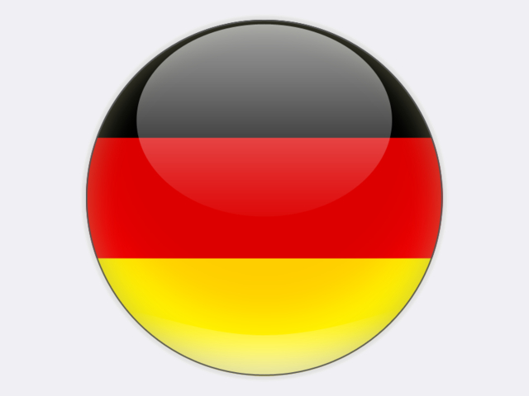

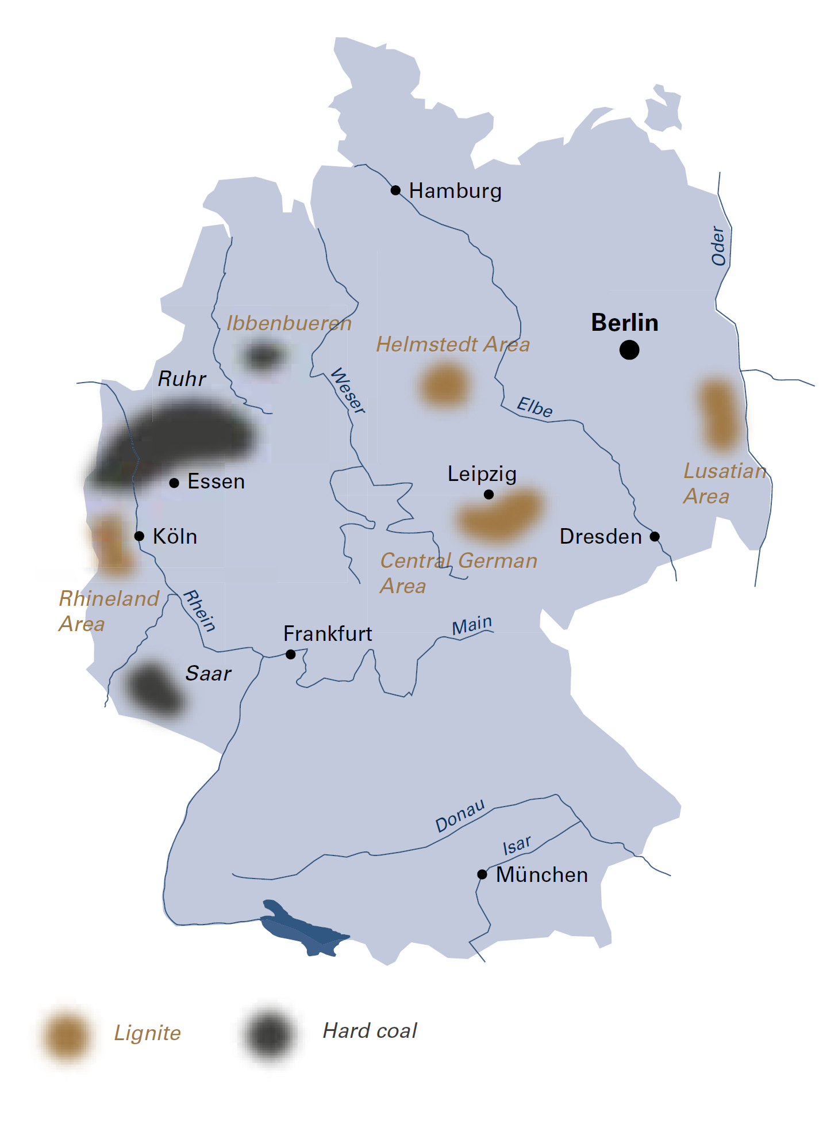

|  |  |  |
| --- | --- | --- |
| General data |  | 2018 |
| Population | million | 82.8 |
| GDP | € billion | 3 344.4 |
| Per capita GDP | €/person | 40 300 |

In November 2016, the federal government agreed a “Climate Protection Plan 2050” (*Klimaschutzplan 2050*) which sets out strategies to reduce greenhouse gas emissions by 55% by 2030 compared with 1990 and by 80% to 95% by 2050. The plan provides for specific reduction targets for each sector for 2030: 61% to 62% for the energy sector. To ensure that implementation of the plan is not uniquely detrimental to the coal-producing regions, the governing parties (CDU/CSU and SPD) decided in their 2018 coalition agreement to establish a “Growth, Structural Change and Employment” Commission”.

This commission was appointed in June 2018. In late January 2019, it presented its final report which *inter alia* includes recommendations for the gradual reduction and eventual phase out of all coal-fired power generation in Germany. According to the commission’s report, a reduction in the installed capacity of lignite and hard coal power plants, to about 15 GW each, should be made by 2022. Compared with the end of 2017, when coal capacity totalled 42.5 GW, this means a decline of almost 5 GW for lignite-fired power plants and of 7.7 GW for hard coal-fired power plants. By 2030, the installed capacity of coal-fired power plants (outside of reserves) is to be reduced to a maximum of 9 GW for lignite and 8 GW for hard coal.

In addition, the commission recommends a complete phase-out of coal-fired power generation in Germany by the end of 2038 – more than ten years earlier than planned. This coal phase-out is to be linked to a number of energy security and social policy conditions which will be verified in 2023, 2026 and 2029. Insofar as certain prerequisites are met with regard to energy-intensive industries, regional employment and economic competitiveness, the date for the final phase-out may be set earlier than 2038, but no earlier than 2035 and subject to negotiations with the power plant operators. Whether an earlier date would be possible will be examined in 2032 under a “flexibility clause”.

In implementing these recommendations, Germany will be prematurely deprived of an important source of electric power for its industrial heartland. These recommendations are, at the same time, a major intervention into the social framework and value creation of the lignite-mining districts. In fact, even without a premature, state-regulated exit from coal, power generation based on lignite in Germany would have ended by no later than 2050.

To decommission lignite-fired power plants, the “Growth, Structural Change and Employment” Commission recommends a contractual agreement with the operators. This should contain compensation payments for the operators and be linked to legal regulations on a socially acceptable phase-out. By late autumn 2019, such agreements between the lignite companies and the federal government should have been negotiated. Hard coal-fired power plant operators should receive a “voluntary premium” through tenders. A bill was presented in autumn, allowing a coal phase-out law to be passed by the end of 2019 or early in 2020. To support the structural change and transition process in the affected coal regions, another bill was presented by the federal government in late summer 2019. It provides for several measures, including state aid up to €40 billion through to 2038 for investments and projects in the affected regions.

The recommendations of the commission also propose incentives for the construction of gas-fired power plants and for the increased use of combined heat and power (CHP) plants. Both are needed in order to ensure security of supply since coal-fired power plants will no longer be available. Additional investments will be needed, for example in open-cycle gas turbines or gas engines.

Until there is a large-scale storage solution for electricity, a combination of power systems will be needed to match the ups and downs of wind and solar PV power generation and so balance supply and demand, because renewable power can be close to zero at times and low for several months.

Figure 24

Coal power plant decommissioning plan of the “Growth, Structural Change and Employment” Commission



## Hard coal

In 2018, the German hard coal market amounted to 48.7 Mtce, of which 27.2 Mtce were used for power and heat generation, while 20.4 Mtce were consumed by the steel industry. The remaining 1.1 Mtce were sold to the residential heating market.

At 46.7 million tonnes, Germany was the EU’s largest hard coal importer in 2018 (32.1 million tonnes of steam coal, 12.4 million tonnes of coking coal and 2.3 million tonnes of coke). The most important sources of imported coal were Russia with a share of 41.1%, followed by the United States, Australia, Colombia, Canada and South Africa.

The German government has phased out – in a socially acceptable manner – all state aid for hard coal production. In 2018, the saleable output from Prosper-Haniel and Ibbenbüren deep mines, the last two mines of RAG DEUTSCHE STEINKOHLE (RAG), totalled 2.8 million tonnes. Both mines closed at the end of 2018. Therefore, Germany’s hard coal production has definitively ended.

Employment figures continue to fall steadily and the number of employees in the hard coal mining sector was 4 125 at the end of 2018.

The core activities of RAG are now: mine water management, repairing subsidence damage due to past coal mining, and the restructuring of former coal mining areas. The private RAG FOUNDATION, created in July 2007, is the owner of RAG and majority owner of EVONIK, a speciality chemicals company. Continuing liabilities after the phase-out of hard coal mining will be financed by the proceeds of the Foundation which also promotes education, science and culture in the mining regions.

## Brown coal and lignite

Lignite supply in 2018 totalled 51.1 Mtce of predominantly domestic production (lignite imports were an insignificant 35 thousand tonnes). Exports of pulverised lignite and briquettes amounted to 1.1 Mtce.

Lignite production, which totalled 166.3 million tonnes (51.4 Mtce) in 2018, was centred in three mining areas, namely the Rhenish mining area around Cologne, Aachen and Mönchengladbach, the Lusatian mining area in south-eastern Brandenburg and north-eastern Saxony, and the Central German mining area in the south-east of Saxony-Anhalt and the north-west of Saxony. In these three mining areas, lignite is exclusively extracted at opencast mines. In 2018, a total of 880 million cubic metres of overburden were moved during mining – an average overburden-to-coal ratio of 5.3 cubic metres per tonne.

Nearly 90% of lignite production is used for power generation (148.2 million tonnes in 2018), accounting for 22.5% of total power generation in Germany. On 1 July 2015, as part of the “Climate Action Programme 2020”, national political leaders, trade unions and the power plant operators jointly agreed that 2 700 MW of lignite-fired power generation capacity would be gradually transferred into a security standby reserve, starting in October 2016 and ending in October 2023. These plants will remain on standby for a period of four years after which they will be closed. These decommissionings will decrease electricity production from lignite by about 15% by 2023 and so reduce lignite demand by about 21 million tonnes, thus reducing greenhouse gas emissions by approximately 21 MtCO2 per year.

Figure 25

Lignite-fired power plants in the security standby reserve



In the Rhineland, RWE POWER AG produced a total of 86.3 million tonnes of lignite in 2018 from its three opencast mines: Hambach, Garzweiler and Inden. Almost 90% of the lignite was consumed at the company’s own power stations, whilst some 10.3 million tonnes were used for processed products. At the end of 2018, the Rhenish mining area had a total workforce of around 10 000.

At the end of March 2018, the district government of Arnsberg approved the main operating plan for the open-pit mine Hambach, covering the 2018-2020 period. Then, in April and June 2018, the German Federation for the Environment and Nature Conservation (BUND or Friends of the Earth Germany) filed a legal complaint against the plan’s approval and initiated an expedited proceeding against the order for immediate enforcement. The Higher Administrative Court of North Rhine-Westphalia ruled on 5 October 2018 that forest clearing should not be carried out in Hambach Forest before a legally enforceable decision had been reached in the BUND case, although other mining operations could continue. No decision has been reached on the factual issue of clarifying Hambach Forest’s fauna-flora habitat status and a final decision on the case might not be available before the end of 2020. Hence, forest clearing is likely only in 2021. For RWE POWER, the interruption to forest clearance has far-reaching consequences. It is expected that the first mining bench will reach Hambach Forest by the end of 2019. At the same time, recultivation measures will be affected, because overburden will not be available. In order to avoid reaching a complete standstill, lignite mining and hence electricity production have been reduced since early 2019. Elsewhere, the “Growth, Structural Change and Employment” Commission recommends keeping Hambach Forest as it is now.

In 2018, gross electricity production at the lignite-fired power plants of the Rhenish District amounted to 72.0 TWh, from a gross installed capacity of 11 489 MW. Two 300 MW Frimmersdorf units (P and Q) were transferred into secure standby from 1 October 2017, followed by two 300 MW Niederaußem units (E and F) from 1 October 2018. A 300 MW Neurath unit (C) was transferred into secure standby by 1 October 2019.

In the Lusatian mining region, the Czech EPH-owned LAUSITZ ENERGIE BERGBAU AG (branded LEAG) extracts lignite at Jänschwalde and Welzow-Süd in Brandenburg, as well as at Nochten and Reichwalde in Saxony with a total output of 60.7 million tonnes in 2018.

Lignite sales to power plants in Lusatia totalled 56.9 million tonnes in 2018. LEAG is the main operator of lignite-fired power plants in the mining area with a total gross capacity of 7 175 MW, including Jänschwalde, Schwarze Pumpe and Boxberg power plants. In 2018, the gross power output from these plants was 53.1 TWh. At the end of 2018, LEAG had a total workforce of around 8 000.

The Central German mining area around Leipzig yielded a total lignite output of 19.2 million tonnes in 2018. The most important company in this area is MITTELDEUTSCHE BRAUNKOHLENGESELLSCHAFT mbH (MIBRAG), owned by the Czech company, EPH. It has two opencast mines at Profen in Saxony Anhalt and Schleenhain in Saxony. The company supplies lignite to its two combined heat and power plants at Deuben and Wählitz with a total capacity of 124 MW, as well as to the larger LEAG/ENBW Lippendorf and UNIPER Schkopau power stations. With a gross capacity of 3 200 MW, these plants generated 20.3 TWh in 2018. At the end of 2018, the Central German mining area had a total workforce of 2 380.

Also in Central Germany, ROMONTA GmbH operates an open-pit lignite mine for crude montan wax production at Amsdorf in Saxony-Anhalt. Montan wax is primarily used in the plastics industry, for the manufacture of cosmetics and cleaning products, and for the hydrophobic treatment of building materials. In addition, montan wax is used as a forming wax in investment casting and as an additive to modify the performance of asphalt and bitumen. Lignite production in 2018 was 466 thousand tonnes. The wax-free fuel is used for power generation at Amsdorf.

Extraction of lignite from opencast mines changes the natural landscape, so land reclamation is an integral part of any mining project. Mining activities are only complete following the transformation of a former “industrial” opencast mine into a vibrant landscape. For more than one hundred years, nature has inspired landscape restoration projects in Germany, including indigenous flora and fauna. Projects that return land to productive use, often with a high recreational and agricultural value, are most typical.

The approved opencast mining plans take into account many issues and ensure a balance between the various interests in the lignite mining areas. Implementation of the “Growth, Structural Change and Employment” Commission’s recommendations may require changes to the existing permits, depending on the nature of the opencast mine sites. It will be a real challenge to find a new balance between the various interests, including agriculture, forestry, local authorities, water management, nature conservation and, last but not least, mining.

The German lignite industry is represented by the Deutscher Braunkohlen-Industrie-Verein e. V. (DEBRIV – the German Brown Coal Association). On behalf of DEBRIV, the German Economic Institute (IW) examined the impact of a stricter national CO2 reduction target on the operation of the EU emissions trading system (ETS) to 2030 and beyond. IW concluded in October 2018 that electricity prices in Germany would rise as a result of the EU ETS reforms adopted earlier in 2018 and that added value and jobs in the lignite industry would be lost because of the higher cost of CO2 emission allowances required for lignite-fired power generation.

An accelerated phase-out of coal, as has now been recommended and is being adopted by the state, will lead to an even larger reduction of added value and jobs in the lignite industry, and indirectly in upstream sectors. The national 55% reduction target for CO2 emissions from the energy sector by 2030 (*c.f.* 1990) would already halve jobs in the German lignite industry by 2025. By 2030, more than two thirds of jobs would be lost. According to IW calculations, around 72 000 direct, indirect and induced jobs depend on the lignite industry, as every job in the industry is linked to almost two more jobs elsewhere in the economy.

Germany

|  |  |  |
| --- | --- | --- |
| Coal resources and reserves |  | as at 1.1.2019 |
| Total resources hard coal | Mt | 82 964 |
| Total resources lignite | Mt | 72 400 |
| Reserves lignite | Mt | 35 900 |

|  |  |  |
| --- | --- | --- |
| Primary energy production |  | 2018 |
| Total primary energy production | Mtce | 160.9 |
| Hard coal (saleable output) | Mt / Mtce | 2.8 / 2.6 |
| Lignite (saleable output) | Mt / Mtce | 166.3 / 51.4 |

|  |  |  |
| --- | --- | --- |
| Saleable coal quality |  |  |
| Hard coal net calorific value | kJ/kg | 30 264 |
| Lignite net calorific value | kJ/kg | 7 000‑11 300 |
| Hard coal ash content | % a.r. | 3.3‑21.0 |
| Lignite ash content | % a.r. | 2.0‑15.0 |
| Hard coal moisture content | % a.r. | 2.5‑13.0 |
| Lignite moisture content | % a.r. | 47.0‑61.0 |
| Hard coal sulphur content | % a.r. | 0.45‑1.8 |
| Lignite sulphur content | % a.r. | 0.12‑2.1 |

|  |  |  |
| --- | --- | --- |
| Coal imports / exports |  | 2018 |
| Hard coal imports | Mt | 44.5 |
| Lignite imports | Mt | 0.0 |

|  |  |  |
| --- | --- | --- |
| Primary energy consumption |  | 2018 |
| Total primary energy consumption | Mtce | 447.2 |
| Hard coal consumption | Mtce | 48.7 |
| Lignite consumption | Mtce | 50.4 |

|  |  |  |
| --- | --- | --- |
| Power supply |  | 2018 |
| Total gross power generation | TWh | 646.8 |
| Net power imports (exports) | TWh | (51.2) |
| Total final power consumption | TWh (est.) | 526.9 |
| Power generation from hard coal | TWh gross | 83.2 |
| Power generation from lignite | TWh gross | 145.5 |
| Hard coal power generation capacity | MW net | 24 462 |
| Lignite power generation capacity | MW net | *20 327 |

|  |  |  |
| --- | --- | --- |
| Employment |  | 2018 |
| Direct in hard coal mining | thousand | 4.125 |
| Direct in lignite mining | thousand | 15.876 |
| Other hard coal-related** | thousand | 15.000 |
| Other lignite-related** | thousand | 4.979 |

* of which 1 973 MW is in a security standby reserve

** e.g. in power generation, equipment supply, services and R&D