# Czech Republic

Since 2014, the Czech Republic has enjoyed real GDP growth of around 3% per year. Over the next few years, GDP is expected to grow at around 2%, driven almost exclusively by domestic demand. Labour shortages constrain faster growth. The Czech government aims to decouple energy consumption from economic growth.

Coal is the only significant indigenous energy resource in the Czech Republic. The country’s proven coal reserves have been estimated to total 705 million tonnes. Brown coal, which accounts for more than 95% of these reserves, is mainly produced in north-western Bohemia, while hard coal is mined in northern Moravia. Significant quantities of hard coal are exported to Slovakia, Poland, Austria and Hungary.

Primary energy supply, which was 61.8 million tonnes of coal equivalent (Mtce) in 2018, comprised: 36.2% coal (22.4 Mtce total of which an estimated 5.7 Mtce was hard coal and 16.4 Mtce was brown coal), 15.8% fossil gas (9.7 Mtce) and 21.6% oil (13.3 Mtce). The primary energy mix also includes nuclear energy with an 18.1% share in 2018 (11.2 Mtce), as well as biofuels and waste which together accounted for 10.2% (6.3 Mtce). Solar, hydro and wind power supplied the remaining 0.9% (0.6 Mtce).

The Czech Republic’s dependence on energy imports has been quite modest to date, but is growing; 37.2% of energy demand was met by imports in 2017. However, imports are structurally imbalanced with around 97% dependence on imported oil and gas. A number of direct and indirect measures are being adopted to reduce energy import dependence, including: increased energy efficiency, the promotion of renewable energy sources which already account for more than the targeted 13% share in final energy consumption by 2020, and the efficient use of indigenous solid fuel resources, mainly brown coal.

In 2018, 49.5% of national gross electricity production of 88.0 TWh came from coal-fired power plants with a total capacity of approximately 10.0 GW, including those using coal gas. Fossil gas-fired power generation had a 4.3% share. Nuclear power plants supplied 34.0% of gross generation and 11.8% came from renewable energy sources including hydro. After rapid growth from 2009 to 2011, output from solar PV has stagnated, with 2.3 TWh in 2018 when output from wind turbines was just 0.6 TWh.

There are five coal mining companies in the Czech Republic, including OSTRAVSKO-KARVINSKÉ DOLY, the only hard coal producer, and four brown coal mining companies: SEVEROČESKÉ DOLY, the biggest producer of brown coal,

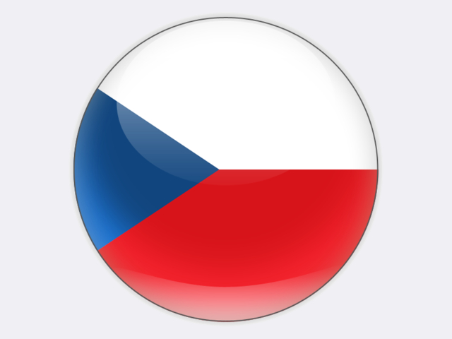

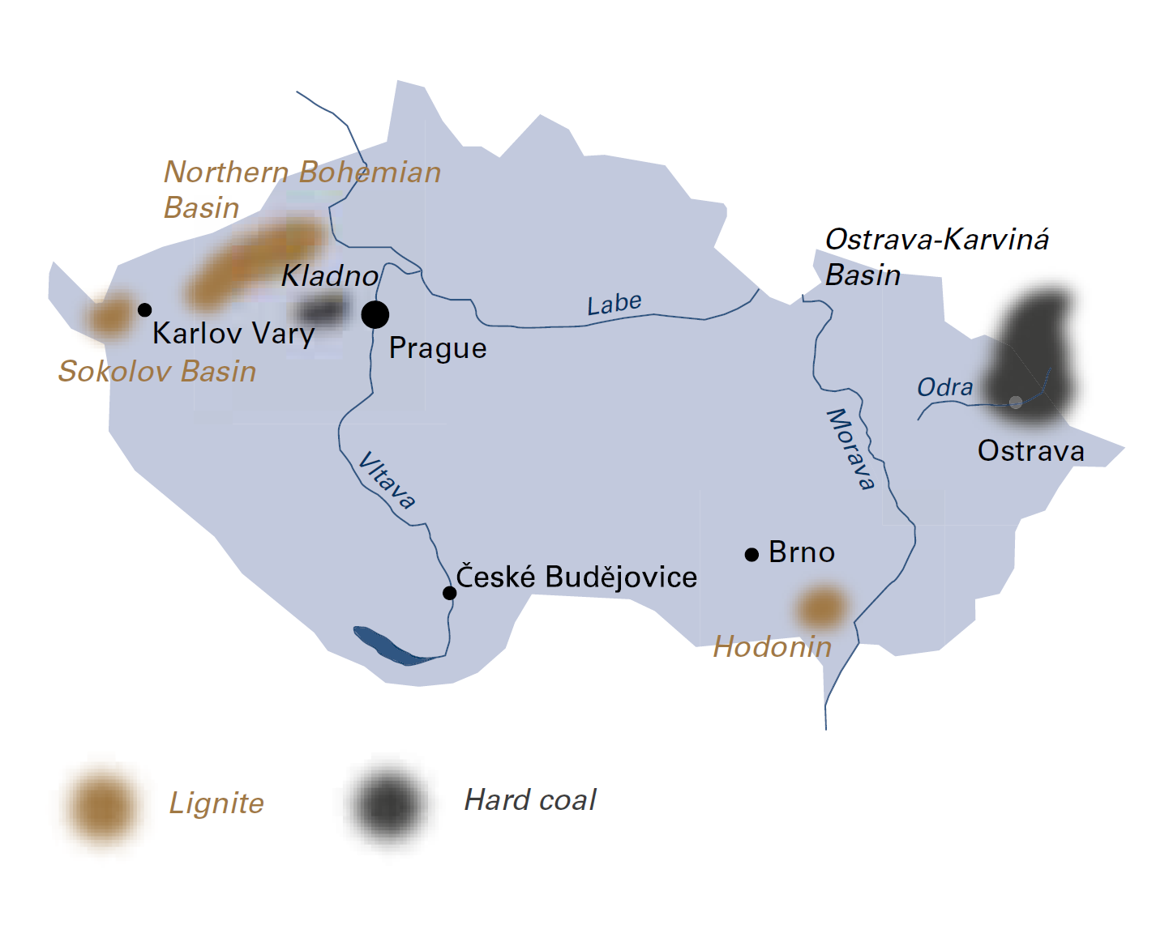

|  |  |  |
| --- | --- | --- |
| General data |  | 2018 |
| Population | million | 10.6 |
| GDP | € billion | 207.8 |
| Per capita GDP | €/person | 19 600 |

owned by ČEZ; VRŠANSKÁ UHELNÁ, with coal reserves to last until 2055; SEVERNÍ ENERGETICKÁ, with the largest brown coal reserves in the Czech Republic; and SOKOLOVSKÁ UHELNÁ, the smallest of the brown coal mining companies. All five companies are publicly listed or in private ownership. The majority state-owned utility company, ČEZ, is the largest coal consumer in the Czech Republic and the most important Czech supplier of electricity.

## Hard coal

The Czech Republic has 23 million tonnes of economically recoverable hard coal reserves, with the largest deposits located in the Upper Silesian coal basin. Having an area of 6 500 square kilometres, this coal basin ranks among the largest in Europe. A major part is located in Poland, while about one sixth (1 200 square kilometres) lies in the Czech Republic where it is called the Ostrava-Karviná basin (after the city of Ostrava and the town of Karviná). Here, OSTRAVSKO-KARVINSKÉ DOLY (OKD) extracts hard coal from three deep mines: Karviná, Darkov and ČSM. A fourth mine, Paskov, stopped production in March 2017. In 2018, OKD’s saleable output was 4.5 million tonnes, with a workforce of 6 895 own employees and 2 200 contractors. The thickness of worked coal seams at Karviná mine ranges from 1.5 to 6.5 metres. Production at OKD mines is mainly longwall with shearer loaders, combined with controlled caving. The last longwall working with a plough finished in October 2019 and “room and pillar” trials have ended. Raw coal is washed in coal preparation plants at ČSM and Darkov mines and is sold as coking coal or steam coal, based on its quality parameters.

## Brown coal and lignite

The Czech Republic has 682 million tonnes of economically recoverable brown coal reserves. In addition to a coal basin in North Bohemia and another basin near the town of Sokolov, there are coalfields in the south of the country, although these are not economically viable. Production of brown coal totalled 39.2 million tonnes in 2018, providing an important contribution to the country’s energy supply.

The main brown coal deposit and the largest mining area, covering 1 400 square kilometres, is the North Bohemian brown coal basin, which is located at the foothills of the Krušné hory mountains, along the border with the German state of Saxony, in the vicinity of the towns of Kadaň, Chomutov, Most, Teplice and Ústí nad Labem. The coal seams in this area lie at depths of up to 400 metres and are between 15 and 30 metres thick.

Brown coal is extracted in the central part of the North Bohemian brown coal basin by two mining companies, VRŠANSKÁ UHELNÁ (VUAS) and SEVERNÍ ENERGETICKÁ (SEAS). Both are members of the vertically integrated SEV.EN ENERGY GROUP and together employ 2 700 people for coal production out of a total group workforce of 3 140 in 2018.

SEAS exploits the country’s largest brown coal deposit at its ČSA surface mine, which holds reserves of 750 million tonnes of good quality brown coal with an energy content of up to 17 500 kJ/kg. These reserves are sufficient to support production for the next one hundred years. However, reserves within the current mining limits, which were approved in 1991, will last until 2024. A total of 3.7 million tonnes was produced in 2018.

VUAS extracts brown coal at the Vršany surface mine. Its coal reserves within existing mining limits have the longest remaining life of any in the Czech Republic. In 2013, the company entered into a fifty-year coal supply agreement with the ČEZ Počerady power station (5 × 200 MW). This long-term contract secures the future of Vršany mine through to its depletion and brings economic stability to the North Bohemian region. In 2018, VUAS extracted 7.8 million tonnes of brown coal.

The SEV.EN ENERGY GROUP also operates the 820 MW Chvaletice brown coal power plant which is undergoing an extensive modernisation programme to reduce emissions and meet stringent European environmental standards with the aim of extending its life to 2030.

Czech Republic

|  |  |  |
| --- | --- | --- |
| Coal resources and reserves |  | as at 1.1.2018 |
| Resources hard coal | Mt | 1 437 |
| Resources lignite | Mt | 2 210 |
| Reserves hard coal | Mt | 23 |
| Reserves lignite | Mt | 682 |

|  |  |  |
| --- | --- | --- |
| Primary energy production |  | 2018 |
| Total primary energy production | Mtce | 39.4 |
| Hard coal (saleable output) | Mt / Mtce | 4.4 / 4.0 |
| Lignite (saleable output) | Mt / Mtce | 39.2 / 16.7 |

|  |  |  |
| --- | --- | --- |
| Saleable coal quality |  |  |
| Hard coal net calorific value | kJ/kg | 25 490‑32 070 |
| Lignite net calorific value | kJ/kg | 11 600‑20 560 |
| Hard coal ash content | % a.r. | 4.3‑18.9 |
| Lignite ash content | % a.r. | 6.0‑37.8 |
| Hard coal moisture content | % a.r. | 3.5‑9.9 |
| Lignite moisture content | % a.r. | 26.5‑38.3 |
| Hard coal sulphur content | % a.r. | 0.42‑0.43 |
| Lignite sulphur content | % a.r. | 0.78‑1.44 |

|  |  |  |
| --- | --- | --- |
| Coal imports / exports |  | 2018 |
| Hard coal imports | Mt | 3.8 |
| Hard coal exports | Mt | 1.9 |

|  |  |  |
| --- | --- | --- |
| Primary energy consumption |  | 2018 |
| Total primary energy consumption | Mtce | 61.8 |
| Hard coal consumption | Mtce | 5.7 |
| Lignite consumption | Mtce | 16.4 |

|  |  |  |
| --- | --- | --- |
| Power supply |  | 2018 |
| Total gross power generation | TWh | 88.0 |
| Net power imports (exports) | TWh | (13.9) |
| Total power consumption | TWh | 74.1 |
| Power generation from hard coal | TWh | 5.8 |
| Power generation from lignite | TWh | 37.7 |
| Hard coal power generation capacity | MW | 1 200 |
| Lignite power generation capacity | MW | 8 450 |

|  |  |  |
| --- | --- | --- |
| Employment |  | 2018 |
| Direct in hard coal mining | thousand | 6.757 |
| Direct in lignite mining | thousand | 7.147 |

In 2019, SEV.EN ENERGY GROUP expanded its portfolio by acquiring two heat and power plants: a 516 MW coal- and gas-fired plant at Kladno near Prague and a 64 MW plant at the city of Zlín in eastern Moravia.

The brown coal mining company SEVEROČESKÉ DOLY (SD) based in the town of Chomutov operates in the North Bohemian brown coal basin, northwest of Prague. SD extracts brown coal at two sites, namely the Tušimice mine and the Bílina mine. A total of 21 million tonnes was produced in 2018, giving SD a 54% share in national brown coal production.

The Tušimice brown coal mine is located between the towns of Chomutov and Kadaň and has an annual production capacity of over 11 million tonnes. After blending at the Tušimice coal preparation plant, the vast majority of the coal produced is supplied to the Tušimice and Prunéřov power stations operated by ČEZ.

The Bílina brown coal mine is located between the towns of Bílina and Duchcov. Each year, over 9 million tonnes of high-quality, low-sulphur brown coal (11 000‑13 000 kJ/kg) are produced and transported to Ledvice power station, CHP plants, district heating plants, industrial users and households.

In 2018, the SD group had a total workforce of 4 841.

Located in western Bohemia, in the western part of the coalfield below the Krušné hory mountains, the brown coal basin around the town of Sokolov is mined by SOKOLOVSKÁ UHELNÁ (SU). The company operates one surface mine, the Jiří mine. In 2018, its output was 6.8 million tonnes. Brown coal from the Sokolov area is mainly used for power and heat generation, with chemical by‑products from coal gasification also being important.

SU generates electricity and heat at two of its own plants: the Vřesová IGCC plant (2 × 200 MWe) and a CHP plant (5 × 270 MWt), which have a combined annual output of 3.5 TWh. Most of the heat produced is consumed by the company itself, although some is supplied to the towns of Karlovy Vary, Nejdek, Chodov and Nová Role. The company also pursues environmental activities, notably the reclamation of land affected by surface mining, as well as waste processing and disposal. SU’s operations employed a total workforce of 2 980 in 2018.

The Czech coal industry has always played and will continue to play a significant role in the national economy. In 2018, the share of coal in gross electricity production amounted to 49.5%. According to the most recent *State Energy Policy*, adopted in May 2015, the share of coal in gross electricity production should decrease to between 11% and 21% by 2040. The *State Energy Policy* will be updated in 2020, based on the recommendations of a Coal Commission established in 2019. With this gradual phasing out of coal-fired power generation, the use of fossil gas, biogas and, prospectively, synthetic methane and hydrogen will increase in the Czech Republic, according to the draft *National Energy and Climate Plan* submitted by the Czech government to the European Commission in December 2018.

To ensure the sustainable use of coal in the future, the Czech Republic is engaged in a comprehensive programme to renovate and renew coal-fired power stations in North Bohemia. The 800 MW Tušimice II power station has been renovated, reducing its CO2 emissions significantly and extending its life to 2035. The life of the 750 MW Prunéřov II power station has also been extended following the renovation of three units, successfully reducing CO2 emissions by 40%. Finally, the new, state-of the-art supercritical 660 MW Ledvice power station, commissioned in 2017, has an efficiency of 42.5%. With a forty-year design life, its 140-metre high boiler house is a Czech landmark.