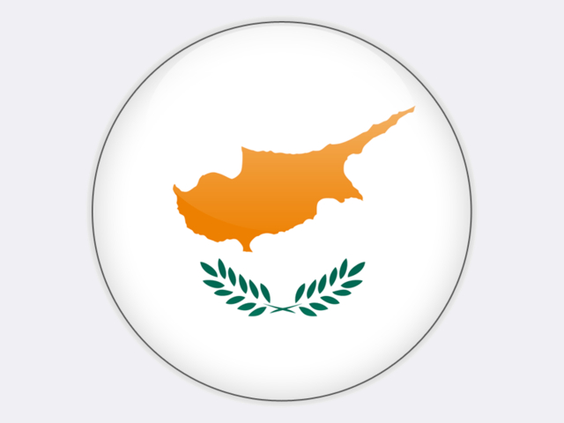

## Cyprus

Cyprus imports small, but growing quantities of hard coal – 22 thousand tonnes in 2018 – for use mainly by VASSILIKO CEMENT WORKS. For its electricity needs, Cyprus is reliant on heavy fuel oil imports costing over 8% of its GDP. Invitations to tender for an LNG import facility were published in 2017. The Maltese government is promoting the 2 GW EuroAsia Interconnector with Israel and Greece which would further diversify energy supply. Significant gasfields in the Levantine basin are now being exploited and if political tensions in the region ease, then Cyprus could exploit the Aphrodite and Calypso gasfields.