## Baltic States

The neighbouring states of Estonia, Latvia and Lithuania lie between the Baltic Sea and Russia. In 2004, these former Soviet states joined the EU and by 2015 all had joined the eurozone. To their south, the Russian enclave of Kaliningrad Oblast borders Lithuania and Poland.

Estonia, Latvia and Lithuania are poised to synchronise with the continental European electricity network in 2025, after gaining formal approval from the European Network of Transmission System Operators (ENSTO-E) in May 2019. Four DC links are already operational: LitPol, NordBalt, Estlink 1 and Estlink 2. The Baltic States will be desynchronised from the Russian IPS/UPS network, leaving Kaliningrad isolated unless DC links are built or the enclave joins the ENTSO-E system.

While no coal is produced in the Baltic States, all three countries consume modest volumes of imported coal, mostly from Russia, and offer important transit routes for Russian coal exported elsewhere.

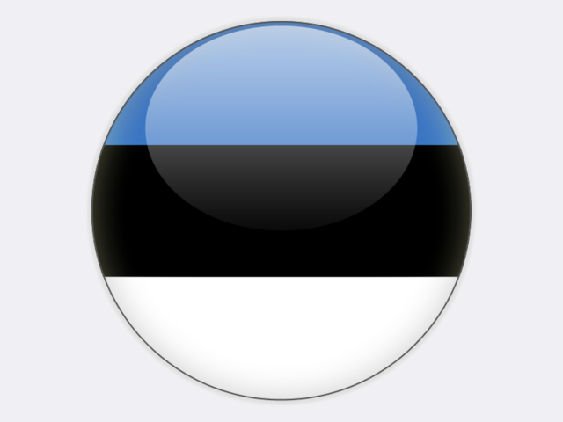

**Estonia** is uniquely dependent on indigenous oil shale for its energy supply and enjoys an energy import dependency of just 4.1%, by far the lowest in the European Union. Large quantities of oil shale are used to generate competitively priced electricity at thermal power plants where it is combusted in much the same way as coal – either as a pulverised fuel in older boilers or in new circulating fluidised-bed boilers (CFBs).

Oil shale is a sedimentary rock containing up to 50% organic matter – Estonian oil shale extracted from the Baltic kukersite deposit has a heating value of 8 000-11 000 kJ/kg and 1.5% to 1.8% sulphur content. Once extracted from the ground, the rock can be either used directly as a fuel in power plants or processed into petroleum products.

Estonia’s accessible oil shale reserves total approximately one billion tonnes. In 2018, 15.9 million tonnes of oil shale (4.4 Mtce) were mined by EESTI ENERGIA and VIRU KEEMIA GRUPP at underground mines and by EESTI ENERGIA, KIVIÕLI KEEMIATÖÖSTUS and KUNDA NORDIC TSEMENT at surface mines. In underground mines, the traditional room-and-pillar mining technology is used. To improve recovery rates and reduce production losses, EESTI ENERGIA is developing a 700‑metre long-wall mining face at an underground mine.

At the beginning of the century, oil shale production was trending upwards to meet growing demand for oil products produced from oil shale. In response, the Estonian government set in 2018 an annual limit for oil shale mining of 20 million tonnes.

In 2018, Estonia generated 10.7 TWh or 83% of its gross electricity supply of 12.9 TWh from oil shale and oil shale gas, a share that is expected to decrease in the future in line with government policy to increase the share of renewables. Around 75% of oil shale production is used for electricity and heat generation, notably at the EESTI ENERGIA Narva energy complex, comprising the 1 615 MW Eesti power plant and the 405 MW Balti power plant which also supplies heat to the town of Narva. Final commissioning of the adjacent 300 MW Auvere power plant was completed by GE in September 2018; it runs on oil shale, biomass, peat and oil shale gas. Four of the eight old units at the Eesti power plant were placed in standby reserve in 2019 due to the high price of allowances under the EU emissions trading system.

The environmental issues associated with oil shale exploitation are complex. With 45% incombustibles, the quantities of ash to store or recycle are large. All old pulverised-fuel boilers operate under limited lifetime derogations or have been upgraded to comply with the EU Industrial Emissions Directive. Balti 11 and Eesti 8 were repowered with CFB boilers and further units have been fitted with a novel integrated desulphurisation system, supplemented with lime injection and deNOx systems.

7 303 people are employed in the Estonian oil shale industry, of which around 3 000 are employed at mines.

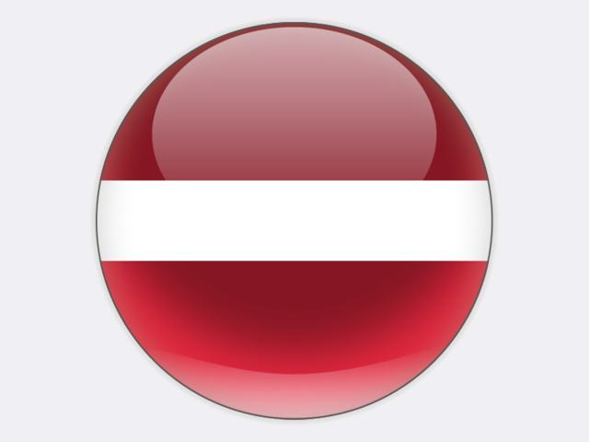

**Latvia** transhipped 20.9 million tonnes of Russian coal exports in 2018: total coal exports from Russia to the EU in 2018 were 67.8 million tonnes. Shipments through the Baltic Coal Terminal at Ventspils were 3.6 million tonnes – lower than the terminal’s annual capacity of 6.0 million tonnes as Russian ports were favoured by exporters. Ust-Luga, 120 km west of St. Petersburg, has become the largest port for coal in the region, although ice can hinder operations there as well as at St. Petersburg and Vyborg (Vysotsk) ports. Alternative routes for Russian coal exports include the ports at Tallinn (Muuga) in Estonia, Riga and Liepāja in Latvia, Klaipėda in Lithuania and Kaliningrad. Klaipėda port is strategically important as the northernmost ice-free port on the eastern coast of the Baltic Sea, with good infrastructure links to Russia. A proposal to expand the Russian Port of Primorsk to handle 25 million tonnes of coal per year would further reduce coal transhipments via the Baltic states.



The population of **Lithuania** has fallen by 17% since the country joined the European Union. Primary energy demand has thus declined to less than 10 million tonnes of coal equivalent in 2018. The country’s energy mix is dominated by imported oil and fossil gas, with only 264 thousand tonnes of imported coal in 2018.

The closure of the Ignalina nuclear power plant at the end of 2009 left a power generation gap in the Baltic region. This could have been filled by the proposed Visaginas nuclear power plant, but Lithuanians vote against this project in a 2012 referendum. Meanwhile, the 2 400 MW Ostrovets nuclear power plant, 50 kilometres from Vilnius, is under construction in Belarus, with pre-commissioning of the first unit taking place since April 2019. Commissioning of the second unit is scheduled to begin in 2020.

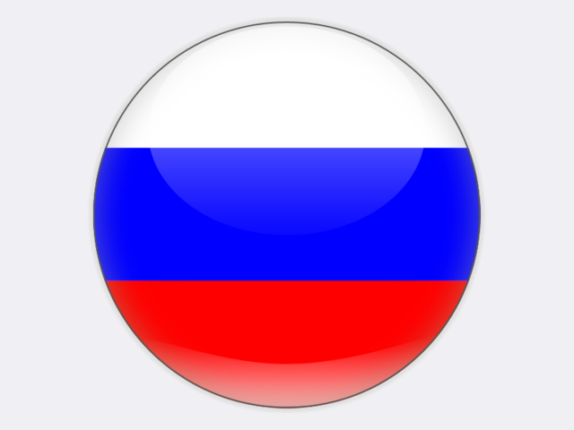

The **Kaliningrad** enclave is dependent on imported energy from Russia, although power is generated locally at the 900 MW gas-fired Kaliningradskaya power plant completed in 2010. To ensure power supply security, the 455 MW Pregolsky gas-fired unit was commissioned in March 2019 as the largest of four new plants with a combined capacity of 1 000 MW: the gas-fired Mayakovskaya and Talakhovskaya plants totalling 312 MW started operation in March 2018, while the coal-fired Primorsky plant should be completed by 2020. The latter will act as a backup. Gas is supplied via a single pipeline from Russia or from a new floating LNG storage and regasification unit. An underground gas-storage reservoir created in salt caverns provides additional security and will be expanded to hold 800 million cubic metres of gas. In May 2019, Kaliningrad’s power grid was temporarily run in isolation to demonstrate its readiness for the future.

Although construction stopped in June 2013 of a new 2 400 MW nuclear power plant at Neman close to the Lithuanian border, it would remain a viable project if customers for its electricity could be found in Germany, Poland and the Baltic states. With three years of civil works completed, major pieces of power plant equipment delivered to the site are being kept in storage, although in 2017 the pressure vessel for unit 1 was sent to replace a damaged vessel at the Ostrovets 2 nuclear power plant in Belarus.