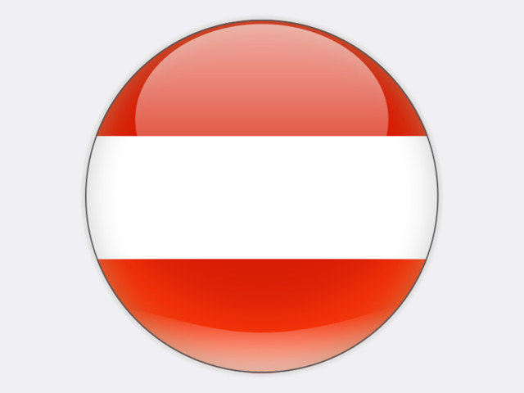

## Austria

Austria has limited primary energy resources and is dependent on energy imports for around two thirds of its primary energy supply. Although no longer exploited, lignite resources total 333 million tonnes, lying mainly in western Styria, near Graz.

During the Monarchy, the country’s energy demand was largely met with coal from Moravia and Silesia. After each world war, hard coal and lignite mining in Austria was expanded to replace production lost elsewhere; lignite output peaked at over 6 million tonnes in 1963 when hard coal output was 100 thousand tonnes. However, with increasing trade and the trend towards greater oil and fossil gas use, Austria’s underground hard coal mines became less competitive and were closed during the 1960s. After more than two centuries, Austrian coal mining ended in 2006 with the re‑cultivation of Oberdorf lignite mine.

Poland, the Czech Republic, the United States, Russia and Australia are the main coal exporters to Austria. In 2018, 3.5 million tonnes of coal were imported, mostly by the power and steel industries. The integrated steel works operated by VOESTALPINE at Linz has an annual crude steel production capacity of 5 million tonnes.

Electricity generation from coal was 3.6 TWh in 2018. However, on 2 August 2019 after almost thirty-three years, EVN ended coal-fired power generation at the 352 MW Dürnrohr power plant in Lower Austria. This followed the closure in April 2015 of a 405 MW unit owned by VERBUND at the same site. A 35 MW (210 MWth) waste-to-energy plant, completed in 2010, continues to operate at Dürnrohr. At Mellach, VERBUND’s 225 MWe coal-fired heat and power plant supplies the city of Graz with district heating. Some progress is being made on repurposing these coal power plant sites for hydrogen production, energy storage, renewable electricity generation and other activities.