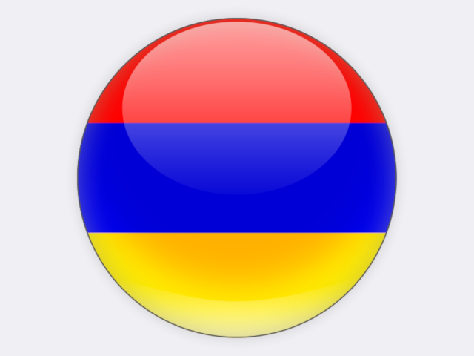

## Armenia

Armenia is a landlocked country in the South Caucasus region, between the Black Sea and the Caspian Sea. In 2017, the majority of the country’s energy supply of 4.6 million tonnes of coal equivalent was imported from Russia, including fossil gas and nuclear fuel for the 376 MW nuclear power plant at Metsamor, 30 km from the capital Yerevan. The main domestic energy source is hydroelectricity. Electricity generation of 7.8 TWh came from roughly equal shares of fossil gas, nuclear and hydro. Total hard coal resources are 317 million tonnes and small deposits of oil and gas exist, but have barely been exploited.