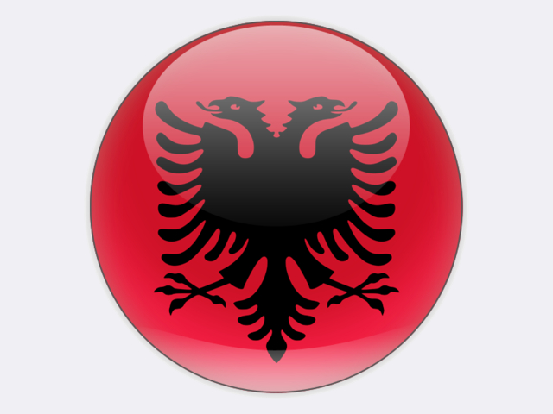

**Albania** produces very small volumes of lignite, about 296 thousand tonnes in 2018, and imports further volumes to meet demand totalling an estimated 430 thousand tonnes at industrial and residential customers, including the Antea cement works. With total resources of 727 million tonnes, the country has the potential to support a much larger coal mining industry. During the 1980s, annual coal production of around 2.4 million tonnes came from mines in central Albania: at Valias, Manëz and Krrabë; at Mborje and Drenovë in the Korçë district; in northern Tepelenë at Memaliaj; and at Alarup to the south of Lake Ohrid.

The country produces all of its electricity at hydro plants with a total capacity of 2.1 GW. A 98 MW gas- / oil-fired thermal power plant at Vlorë is currently inoperable. Imported electricity covers around 40% of total electricity supply.

The Trans-Adriatic Pipeline (TAP), which will deliver Azeri gas via Greece and Albania to Europe, is expected to create a demand for fossil gas in Albania. Construction of the TAP is scheduled to finish in 2019, with first gas deliveries to Italy expected in 2020.

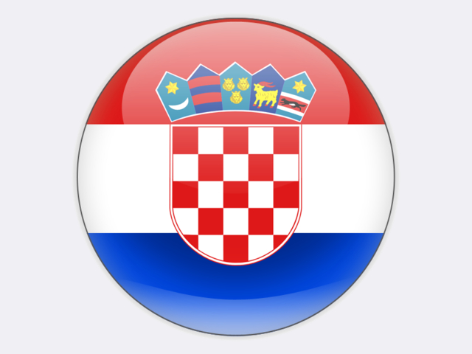

**Croatia** became the newest member state of the European Union on 1 July 2013. The country does not produce coal, but consumed 595 thousand tonnes of imported coal in 2018, mainly at the 335 MW Plomin I and II power plant which is 100% owned by HRVATSKA ELEKTROPRIVREDA (HEP). Coal accounted for 9% of total generation in 2017. In February 2018, HEP applied for a permit to modernise the 125 MW Plomin I unit to extend its life by 15-20 years. Plans for a third 500 MW unit at Plomin were cancelled in 2016.



**Kosovo** is governed by the United Nations Interim Administration Mission in Kosovo (UNMIK), following the violent conflict of 1996-99. It has very large lignite resources, totalling 10.8 billion tonnes and fourth only to Poland, Germany and Serbia in Europe. Reserves are located in the Kosova, Dukagjini, Drenica and Skenderaj basins, although mining has been limited to the Kosova basin to date. Lignite production in 2018 was 7.2 million tonnes.

For electricity, Kosovo was 93.2% dependent on lignite in 2017, with the rest coming from hydro plants and imports, including from a 32 MW hydro plant at Ujman/Gazivoda and other smaller plants.

The state-owned KORPORATA ENERGJETIKE e KOSOVËS (KEK) has a monopoly position in lignite mining and electricity generation. The Kosova A (comprising five units of which the 200 MW unit A3 and 2 × 210 MW units A4 and A5 are operational) and Kosova B (2 × 339 MW units) power plants near Pristina are supplied with lignite from Sibovc Southwest mine near Obilić which opened in 2010.

In December 2014, a successful bid for the new 500 MW “Kosova e Re” thermal power plant (a.k.a. Kosovo C) was submitted by CONTOUR GLOBAL of the United States to the Kosovan Ministry of Economic Development. This €1.2 billion project will replace Kosova A and will, with the development of the Sibovc mine, create 10 000 jobs, improve the environment and end the electricity blackouts that plague the country. In May 2019, GENERAL ELECTRIC was chosen to build Kosovo C with construction expected to start late in 2019.

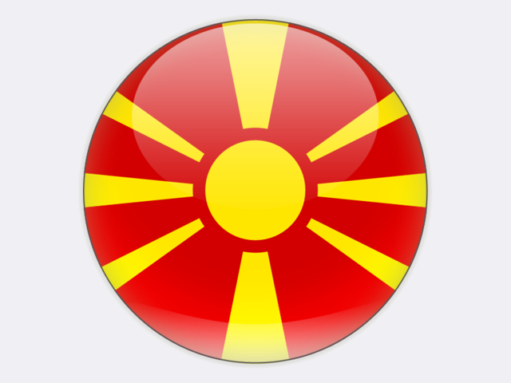

**North Macedonia** is a significant lignite producer: 5.0 million tonnes in 2018 from the Suvodol and Oslomej surface mines of state-owned ELEKTRANI NA SEVERNA MAKEDONIJA (ESM) and a number of smaller, privately owned surface mines. Coal resources are estimated at 632 million tonnes in the Pelagonija and Kicevo basins, including deposits at Suvodol, Brod-Gneotino, Zhivojno, Oslomej, Popovjani and Stragomiste. Lignite from the Mariovo basin may be exploited to fuel a proposed new 300 MW power plant at Mariovo. In Mach 2019, tenders were invited for a 10 MW solar PV farm at the Oslomej mine.

Most coal and lignite is used for power generation which accounted for 54.0% of gross generation in 2017, mainly at the 675 MW ESM Bitola and 125 MW ESM Oslomej power plants. The balance is used almost entirely by the steel industry, including the DOJRAN STEEL plant at Nikolic, DUFERCO MAKSTIL’s integrated steel works at Skopje, and ARCELORMITTAL’s steel mill, also at Skopje.

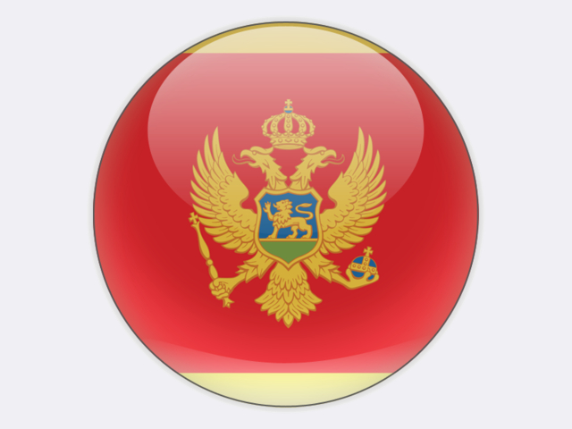

**Montenegro** produced and consumed 1.6 million tonnes of lignite in 2018, mostly for power generation – 1.4 TWh in 2017, this being 54.8% of gross generation. Hydro power supplied 41.1% with the remainder coming from wind and solar PV. Although not currently exploited, Montenegro has hard coal resources of 337 million tonnes.

Montenegro’s 225 MW Pljevlja coal-fired power plant, commissioned in 1982 and owned by the majority state-owned company ELEKTROPRIVREDA CRNE GORE (EPCG), is supplied with brown coal (10 300 kJ/kg) from two surface mines operated by RUDNIK UGLJA PLJEVLJA employing 861, including contractors, and 100% owned by EPCG since June 2018. Under an agreement with the Energy Community on implementation of EU law, the unit may operate for 20 000 hours over the period 2018-2024. In March 2019, a contract was placed with STEAG ENERGY SERVICES of Germany to further upgrade the unit with flue gas desulphurisation and deNOx to meet the latest EU emission standards and thus extend the operational life of the plant. A heat offtake for district heating in Pljevlja is included in the upgrade. Earlier plans to construct a new unit have been put on hold and a contract with SKODA PRAHA for a new 254 MW unit was terminated at the end of 2017.

In 2014, METALFER acquired an underground coal mine at Berane which had been flooded and idle since 2005. Exploitable reserves are estimated at over 50 million tonnes of brown coal with a calorific value of 14 000-17 000 kJ/kg. In January 2015, commercial mining restarted at a depth of 200 metres, employing 140 people. Production in 2018 was 56 448 tonnes.